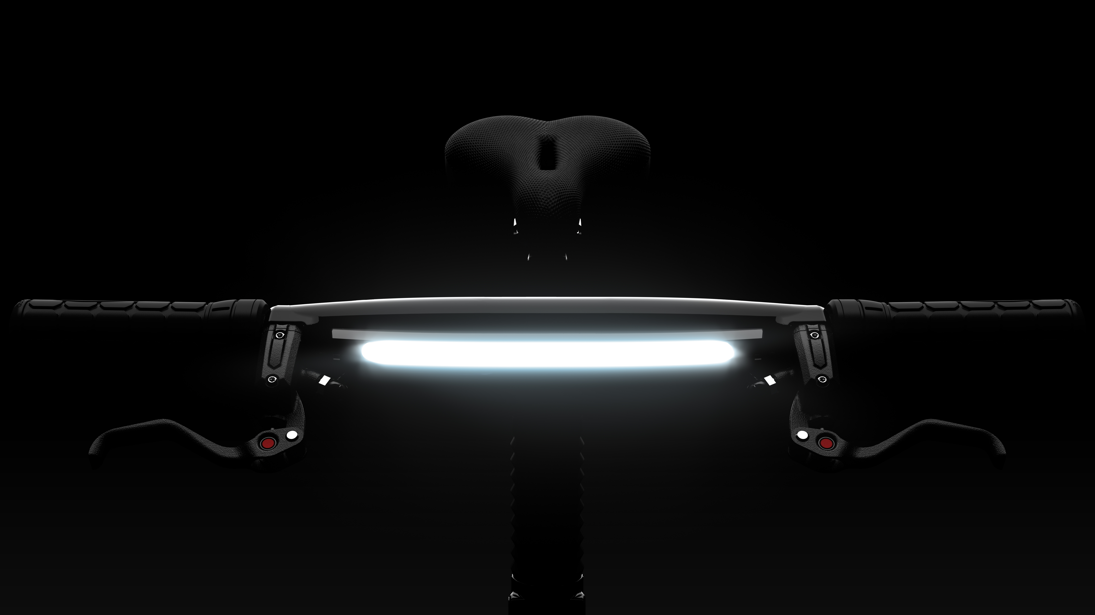Press Release
Karbon Kinetics Announces Third-Generation Gocycle® G3 for 2016
LONDON, 15 August 2016: Karbon Kinetics Ltd. (KKL) today announced the introduction of its third-generation Gocycle® G3 with integrated automotive-inspired daytime running light (DRL) employing light pipe technology.
In order to increase the visibility of cars and improve safety for road users, as of 2011, European law mandates that all automobiles have DRLs. The new Gocycle G3 now comes fitted with an automotive-inspired DRL.
Richard Thorpe, designer of Gocycle, commented, “We’ve brought automotive style DRL technology to e-bikes, aiming to improve the visibility and safety of G3 riders. Our proprietary light pipe design gives the new G3 a distinctive visual signature not seen on any other e-bike in production today.”
There is a difference between a DRL and a traditional bicycle night light. A DRL generally improves the visibility of the vehicle to other road users—it is a “to be seen” light primarily running during the daytime; whereas a night light typically illuminates the road in front of the rider—a so called “to see” light running at night. But DRLs should not be too bright, especially if running at night, and they should not exceed limits set forth for traditional “to see” night lights to prevent “dazzling” other road users.
Thorpe continued, “It’s not straight forward for e-bike designers and manufacturers to integrate a DRL into an e-bike because existing lighting standards are complex, not harmonized across Europe, and are lagging behind new LED and DRL technology. E-bikes have onboard battery packs and electronics that are more than capable of supporting and controlling lights operating continuously during the day and night. So integrated DRL’s make sense on and e-bike and can improve safety.”
“We’re excited to lead the market in this area of e-bike development. While the new G3 DRL does not exceed existing limits and is designed to work with approved “to see” lighting systems, the industry would benefit from an improved lighting standard that is up to date with the latest safety and light technology such as DRLs. We’d like to work with stakeholders to contribute to an e-bike DRL standard,” said Thorpe.
Besides the addition of the integrated DRL, the Gocycle G3 builds on the success and experience of the award-winning Gocycle G1 and Gocycle G2 and has more than 60 advancements. The cockpit has been redeveloped with more comfortable, ergonomic grips, as well as bespoke four-way, rotary twist controls for shifting, power and DRL control. A new KKL-developed BMS (battery management system) supports a higher capacity G3 battery pack. The G3’s many other upgrades include proprietary innovations such as the PitstopLock™ system for the PitstopWheel® and the all new Portable Docking Station, which makes stowing and transport easy as well as offering integration with automotive and marine vehicles.
Gocycle G3 is available for purchase now through select resellers throughout the USA. (See http://gocycle.com/store-locator).
MSRP:
$4,499
Press Contact
For more information, please contact sales@gocycle.com. To download product images, visit www.gocycle.com.
Download the G3 technical product brochure here: http://view.intellimag.com/go/g3-product/
About Karbon Kinetics Limited
Karbon Kinetics Limited was founded in 2002 with a mission to develop the world’s most innovate and technologically advanced electric bicycle. Using automotive engineering and design, KKL has produced Gocycle®, the award-winning electric two-wheeler that is shaking up the electric bicycle industry.
Gocycle is the brainchild of Richard Thorpe, a former McLaren Cars design engineer with a 25- year career working in the motorsports and light electric vehicle industry.
After an extensive and in-depth product development process, Karbon Kinetics’ critically acclaimed breakthrough product Gocycle was first made available to the public in April 2009. Inspired by F1 high performance and design, Gocycle is the first injection-moulded magnesium alloy bicycle in history. Lightest in class, environmentally sustainable and stylish with on-demand electric power, Gocycle is an automotive joy to live with. Ergonomic, elegant, lightweight, ingenious and fun—a talking point wherever it goes.
Company Fast Facts:
- January 2002: Karbon Kinetics Limited is founded by former McLaren Cars design engineer Richard Thorpe.
- March 2008: Gocycle G1 wins awards for Best Innovation and Best Complete Bicycle at Taipei International Cycle Show.
- January 2009: Gocycle G1 wins Bicycle Innovation Award at FietsVAK, Amsterdam.
- April 2009: Gocycle G1 launches in Europe to international media acclaim.
- September 2009: Gocycle G1 wins IF GOLD Award in the electric bicycle category at EUROBIKE, Germany.
- February 2011: The first-generation Gocycle G1 is now sold out!
- September 2011: Karbon Kinetics announces Gocycle G2 specifications.
- August 2012: Karbon Kinetics premieres the Gocycle G2 at EUROBIKE 2012.
- August 2012: Gocycle G2 is awarded the EUROBIKE Award honouring innovation in the bicycle industry.
- March 2015: Gocycle G2 is awarded the Red Dot Product Design 2015 award.
- January 2016: Gocycle G3 introduced in Europe.
www.gocycle.com
