FOR IMMEDIATE RELEASE

Contact: Megan Licursi Donna Gray
MLMC Melitta North America
513.404.2545 727.524.4816
megan@licursi.net donna.gray@melitta.com

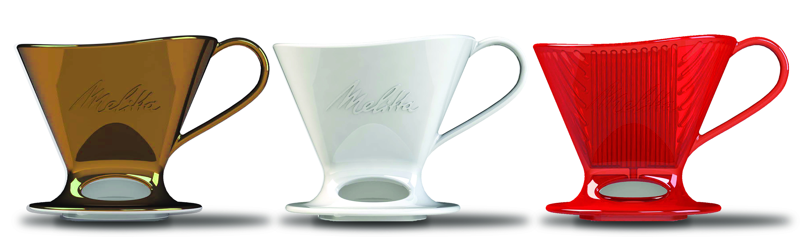

Melitta North America Builds on Heritage, Launches Signature Series Pour-Over™ for the Perfect Cup of Coffee
New line of Pour-Over coffeemakers allows customers to experience handcrafted coffee at home

CLEARWATER, FL—February 2, 2017— Melitta North America, a household name in exceptional coffee preparation, today announced the launch of its Signature Series Pour-Over™ coffeemakers designed for customers in pursuit of a better cup of coffee, in the comfort of their own home.
“As the inventor of the original Pour-Over™, Melitta North America is excited to introduce this new line of Pour-Over™ coffeemakers to coffee lovers throughout North America,” said Chris Hillman, VP of Marketing. “More than a century of research and development have culminated in our Signature Series Pour-Over™ line which combines function and design to deliver brewing simplicity—and, of course, a better cup of coffee.”
Melitta Bentz, the brand’s innovative founder, revolutionized the world of coffee in 1908 when she took a brass pot from her kitchen, punched holes in it and used a piece of paper from her son’s notebook to create the very first Pour-Over™—the precursor to the modern day Pour-Over™.
“It’s Melitta Bentz’ legacy that we’re building on,” said Hillman. “Her iconic Pour-Over concept still gives our customers the simplest way to enjoy handcrafted coffee at home, eliminating the guesswork and minimizing the cleanup. Our Signature Series Pour-Over™ is the best option for customers looking for flavorful, gourmet brewing at home without bitterness or mess.”
The Signature Series Pour-Over™ brews a single cup of handcrafted coffee in three simple, efficient steps:
- Place the Melitta Pour-Over™ cone on top of your favorite mug and insert Melitta paper filter.
- Scoop in your favorite fresh ground coffee to taste.
- Pour hot water (just off the boil) into the cone, fully saturating all the grounds.
Then, just sip, smile and enjoy the pure flavor of handcrafted coffee.
All of Melitta’s Signature Series Pour-Over™ coffeemakers feature a functional design optimized to ensure consistent brewing results. Two viewing windows provide visibility into the mug preventing unnecessary messes.
The Melitta Pour-Over™ line will have a starting MSRP of $19.99 and will be available in department and specialty retailers beginning in Fall of 2017.
The Melitta Pour-Over will be on display at the 2017 International Housewares Show in Booth L11926 in the Lakeside Pavilion.

About Melitta North America
For more than 100 years, Melitta has dedicated itself to providing the ultimate coffee experience with its premium line of coffee, coffee filters and high quality coffeemakers, bringing European indulgence to life. The company was founded in 1908 by Melitta Bentz, after receiving a patent for her coffee filtering system consisting of a filter and filtration paper. The filter system was the first to successfully remove coffee residue in the brewing process, revolutionizing the way coffee was made. Melitta North America, Inc., part of the privately held Melitta Group in Minden, Germany, is headquartered in Clearwater, Florida. Melitta USA—a division of Melitta North America—produces coffee and filters in North America and markets the line in the U.S. For more information, visit www.melitta.com and follow the flavor: @MelittaUSA on Facebook, Instagram, Twitter and Pinterest.

