Press Release
Media Contact:
Productivity PR, Inc (818) 223-9046 info@productivitypr.com
www.productivity.net

Miniwing Rolls Out Camile R100 Bike Camera
The all-new bike camera can take still pictures, video
and keeps track of your ride with the onboard GPS.

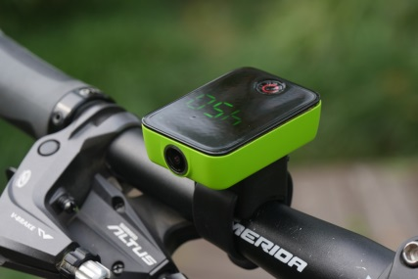
Torrance, CA (June 2016) – While bicycling remains as a very popular pastime recreational activity, it has also grown into a preferred mode of transportation among Millennials and teenagers as it is less expensive and more environmentally friendly than driving a motor vehicle. In fact, according to the U.S. Department of Transportation, as the usage of bikes as a means of transportation continues to increase, so have injuries and accidents involving bicyclists. In 2013 alone, more than 48,000 cyclists were injured in incidents which involved a motor vehicle. Because of this new trend, it is advisable that cyclists outfit their bike with a camera so that they can document any incidents. As a response, MiniWing has developed the new Camile R100 sports camera designed especially for bicycles so cyclists are now able to capture the beauty of their ride or document an unforeseeable incident and immediately download, view or stream their footage with any mobile device.
The Camile R100 secures easily onto any bike handlebars to capture images or record in HD 1080p/30fps or 720p/60fps video through a 149-degree wide-angle lens to help you record every wonderful moment or document safety concerns during a ride. Cyclists can choose between two separate modes that can be set by the push of a single button: video mode or burst shooting mode, which can be set in intervals between 3 and 60 seconds. Once turned on, an LED screen can display the speed of travel, local time, the mileage of a trip, notify of an incoming call, or allow the rider to reject a phone call. Three indicator lights also indicate battery life, video recording and if it is connected via WiFi or Bluetooth to a smartphone.
Available in five colors, Camile’s GPS technology features 6-axis motion and altimeter sensors to quickly and accurately capture cyclists’ rides in a 3D orientation. Once the footage has been shot, an application is available to sync all of the footage via a WiFi connection or can be then downloaded to a computer with a USB cable. Also included with the camera is a base holder that can attach to any bike, and a built-in rechargeable 1200mAh lithium battery, which supports 3 hours video recording and up to 16 hours of still photos and speedometer operation on a single charge.

The Camile R100 will be available through Amazon this summer for $169 (USD). For more information, please visit http://www.miniwing.com/index.php/en
###

