For Immediate Release
January 2, 2018

Polymer Injection Molding Produces 2 ½ Million Gunstocks

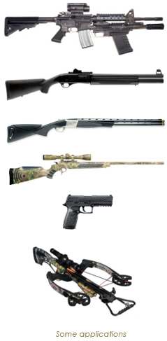
Palmer MA (January 2, 2018). Polymer Injection Molding, a leading manufacturer of synthetic components for firearms, announced today that it has achieved a significant milestone—the production of 2 ½ million gunstocks. The company manufactures gunstocks, pistol frames, recoil pads, and other components for outdoor sports, law enforcement, and national security firearms applications. It also provides many value-added services such as in-house camo dipping, painting, pad printing, shielding, and assembly. Polymer’s customers are a who’s who of the firearms industry. Among them are Browning, Savage, Sig Sauer, Smith & Wesson, and Sturm Ruger. Polymer is ISO 9001:2008, AS9100, ITAR, and UL registered, and has a Federal Firearms License, US Government CAGE Code, and significant Mil-SPEC experience. Learn more about Polymer at www.polymercorporation.com .

Polymer will be participating in the SHOT Show Supplier Showcase on Monday and Tuesday January 22-23. Stop by to see us then at Booth S2026 or contact us at 781-347-5690 to set up an appointment to see us later in the show.

###

