Taber Extrusions Returns to 2019 SHOT Show With Customizable Extrusions for AR-15 Variant Rifles

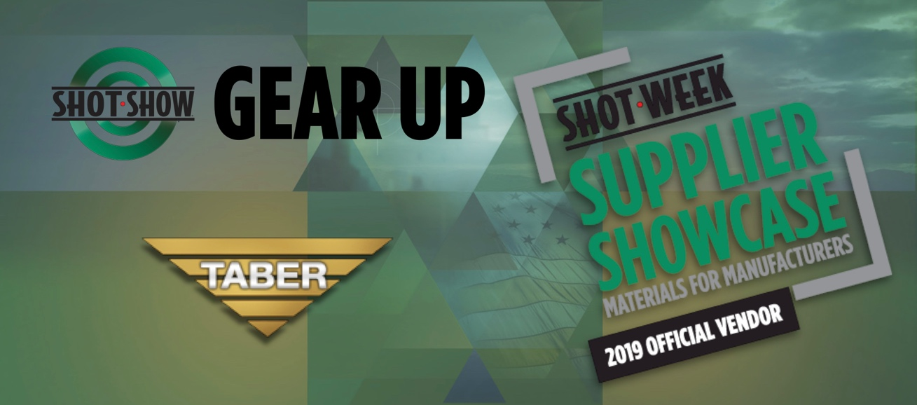

Las Vegas, Nevada – January 22rd – 25th Aluminum Extrusion leader Taber Extrusions returns to Las Vegas for the 2019 SHOT Show at the Sands Expo Convention Center, the largest trade show of its kind in the world, attracting attendees from more than 100 countries. Sponsored by the National Shooting Sports Foundation trade association for the firearms, ammunition, hunting, and shooting sports industry, The SHOT Show hosts leading manufactures who come to showcase their newest products and innovations.

Taber Extrusions will be located at booth S1420 within the Shot Show Supplier Showcase, providing information on their customizable aluminum extrusions for the manufacturing of AR-15 variant rifles, lightweight pistol frames, as well as components for optics and other aftermarket accessories. Taber offers standard AR-15 shapes as well as custom profiles. Taber extruded profiles are made from the same material used in fighter jets and space vehicles, namely aluminum alloys from 2xxx, 6xxx or 7xxx families. Taber’s AR-15 profiles are perfect for the progressive fabricator looking to accommodate multiple design features, and Taber will be available to answer questions at the 2019 Supplier Showcase, providing information on the wide scope of other offerings in the realm of aluminum extrusions relating to the firearms industry.

The Supplier Showcase was launched at the 2017 SHOT Show to allow material and service suppliers to meet directly with the manufacturing community. Nearly 3,000 manufacturing-related attendees visited the Supplier Showcase in 2018 to meet with current suppliers, identify new suppliers, and find new resources to improve their supply chain. Due to overwhelming demand from both suppliers and manufacturers, the Supplier Showcase is open two full days, January 21–22, 2019 8:30 AM–5:30 PM in Palazzo Ballroom, 5th Floor Venetian Hotel Meeting Rooms.

Taber Extrusions a minority business enterprise, fully integrated with In-house casting, extrusion, and fabrication, IS0 9001, AS9100, and NADCAP certified, and offers alloys in 2xxx, 5xxx, 6xxx, and 7xxx series with extrusion sizes ranging from less than 1 lb./ft. up to 140 lbs./ft. Recently featured in Light Metal Age Magazine for both their casthouse modernization & micro-extrusion capabilities, Taber is a leading supplier of aluminum extrusions purposed for Military and Department of Defense, and offers a diverse range of products and services while simultaneously maintaining a high level of customer care and support.
Meet Taber at the 2019 Shot Show Supplier Showcase from January 22rd – 23rd from 9am-5pm in the Palazzo Ballroom, 5th floor Venetian Hotel Meeting rooms – booth S1420. The Venetian Hotel is located at 3355 South Las Vegas Blvd. Las Vegas, NV. 8910. Connect at www.taberextrusions.com or call Taber directly at 888.985.5332.
###

