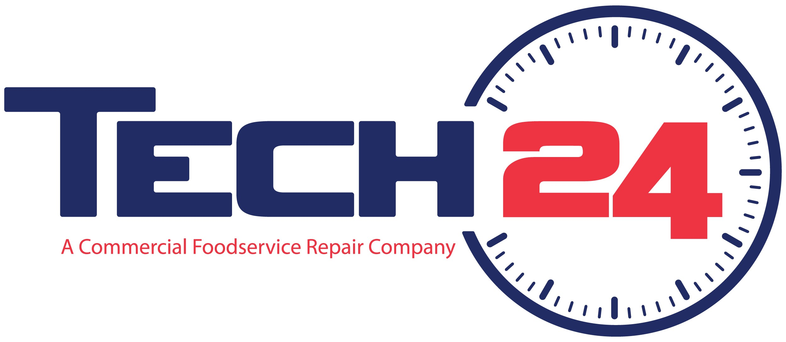

For immediate release

Media contact:
Corey Harrison, VP of Sales & Marketing, Tech 24
864.271.6522
corey@mytech24.com

Tech-24 Acquires Service Solutions Group from Franke Foodservice Systems,
Forming Industry’s Largest Independent Service and Repair Company

(GREENVILLE, SC, November 3, 2015) - Tech-24, a national leader in commercial foodservice equipment repair, has acquired Service Solutions Group. SSG is a foodservice equipment repair company owned by Franke Foodservice Systems, based in Smyrna, TN and active in 23 markets across the country, including Arizona, California, Iowa, Kentucky, Ohio and New England. Tech-24 and Franke expect to continue working closely together to meet SSG customer needs.

The deal makes Tech-24, headquartered in Greenville, SC, the industry’s largest independent service and repair company. Tech-24’s 485+ service technicians and longstanding network of over 600 service partners provide coast-to-coast coverage to leading QSRs, full-service restaurants, convenience stores, hotels, concessions operations and corporate clients.

“We like the way Keith Burke and his team at SSG do business,” said Kurt Herwald, Tech 24 President and CEO. “They share our primary objective — to build a great service company whose only goal is to fix the customer’s problem.”

As Herwald notes, the combined companies will be even more formidable together, with 230+ CFESA technicians, including 135 master certified technicians, over $16 million in parts on the shelf, and multiple distribution centers. “We’re in most of the nation’s largest metro markets, with offices in 18 of the 20 largest markets, giving us a unique ability to service chain customers as well as independent operators.”

“We’re excited about the fit between CFR and SSG, and the opportunities for Keith and the SSG team to grow and prosper as part of a high-performing service business,” said Tom Campion, CEO of Franke Foodservice Systems. “Our strategy today is more focused on our core equipment and supplies design, manufacturing and distribution activities. As such, we’ve been seeking an exit from our direct service activities for some time.”

Looking forward, Tech-24 sees opportunities for additional acquisitions. “We have the management and infrastructure in place to integrate more companies,” Herwald said. “We’ll grow organically and through acquisition to meet the changing needs of our customers and OEM partners.”

For more information or to arrange an interview with Tech-24 senior management, contact Corey Harrison, Tech-24 VP of Sales & Marketing, at 864.271.6522 or corey@mytech24.com.

About Tech-24
Headquartered in Greenville, SC, Tech-24, formerly known as Commercial Foodservice Repair, Inc., is a leading independent provider of service and repairs for foodservice customers, including convenience stores, QSRs, full-service restaurants and concessions operators. The company merged with Tech-24 in July of 2014 and has service locations across the U.S., offering 24/7 service and repair on a national, regional and local basis. Additional information is available online at www.mytech24.com.

About Service Solutions Group
SSG is a leading service provider for foodservice customers from California to Massachusetts. The company provides service, parts, equipment installation and preventive maintenance programs for commercial refrigeration, cooking equipment and HVAC systems. Additional information is available at www.servicesg.com.

About Franke
Franke belongs to the Artemis Group and is a leading global provider of solutions and equipment for domestic kitchens, private bathrooms, semi-/public washrooms, professional food service, coffee preparation and beverage delivery. The Franke Group operates worldwide and employs around 9,000 people in 37 countries, generating sales of around CHF 2.1 billion. Additional information is available at www.franke.com.

# # #

