THEOUTDOORWIRE RELEASE
Contact Dennis Milinazzo  Telephone 1-877-281-3783  Cell 505-270-4637  Email dmilinazzo@ergogrips.net  Website Ergogrips.net | FOR RELEASE  December 17, 2018

ERGO Celebrates 20th BIRTHDAY

DEC 15TH, 2018 MARKS A NEW MILESTONE FOR GRIP & ACCESSORY MANUFACTURER
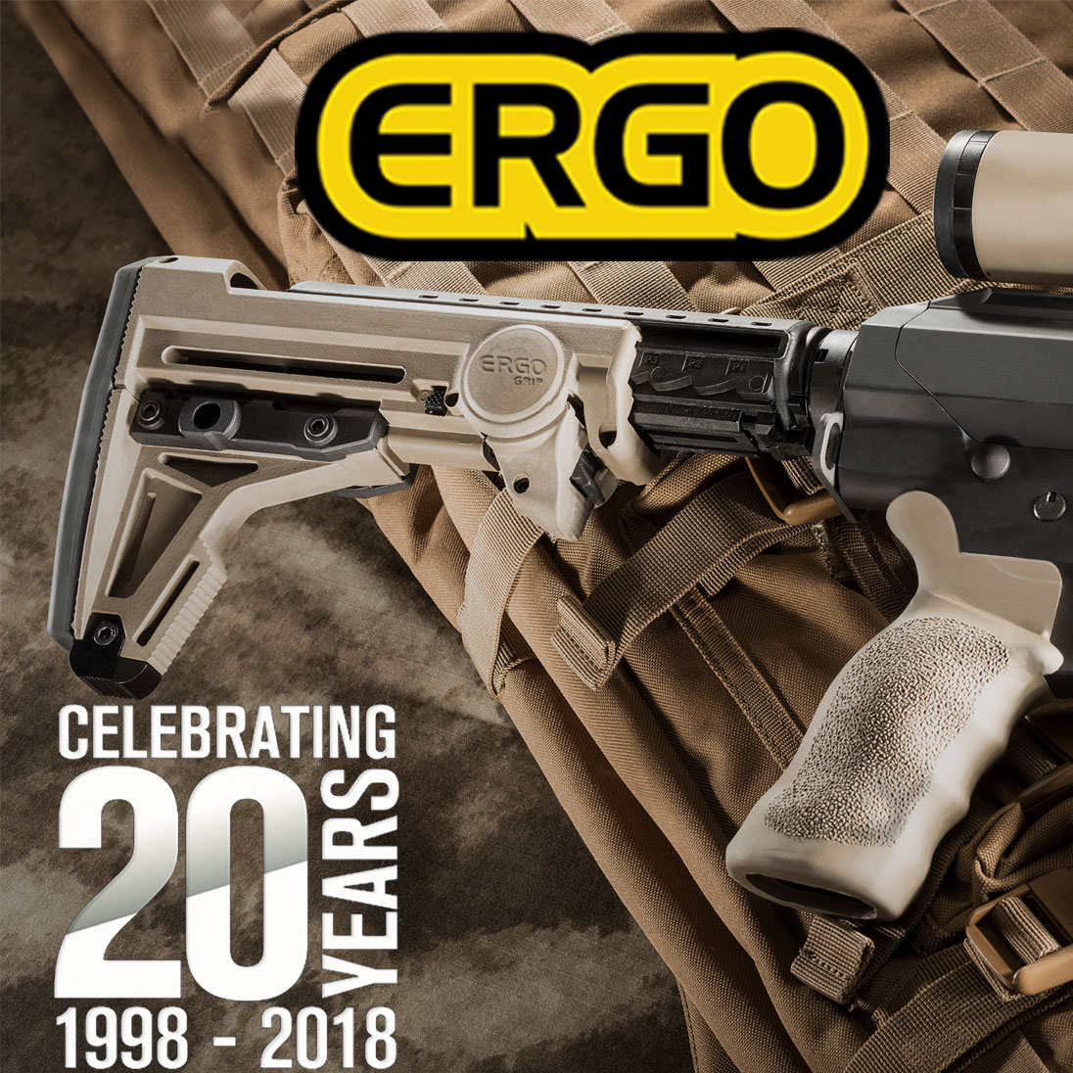
Moriarty, NM, December 17, 2018 – ERGO is proud to announce our twentieth year as a leading firearm accessory manufacturer. In an era where companies in the firearm industry come and go, ERGO has achieved two decades of innovation and steady growth. We’re celebrating the occasion with a company party at the ERGO headquarters in Moriarty, NM.
ERGO began in December of 1998 when founder Steve Hines released the Original ERGO Grip to the world. It was the finest textured and overmolded AR grip designed to increase shooter accuracy and comfort. The early success of the Original ERGO Grip indicated a growing demand for ergonomic grips and AR accessories. Seeing the opportunity, ERGO developed and introduced several revolutionary products to the firearm world, including the Tactical Deluxe Grip, F93 Pro Stock, Rail Covers, Rail Systems, and AK Grips.
Expanding our horizons
Over the years we’ve developed new products for AR's, AK's, Remington & Mossberg shotguns, 1911's, & revolvers. Most recently we’ve introduced the ERGO Shotgun Stock Adapters for Mossberg and Remington shotguns. ERGO Shotgun Stock Adapters allow the user to fit AR grips & stocks on their shotgun.
Our continual improvement of existing products and development of new ones reflects our ongoing commitment to delivering innovative, high-quality, American made products for firearms.
ERGO is Proudly Made in the USA
Every ERGO product is designed, manufactured, and packaged in the USA, built tough to withstand a lifetime of use. We also back every ERGO product with our lifetime guarantee.
ERGO is a US manufacturer of top quality grips and accessories for your AR's, AK's, Remington & Mossberg shotguns, 1911's, & revolvers. 100% made in the USA with top quality materials and we support all of our products with a Lifetime Guarantee. For over 20 years ERGO has focused on quality upgrades for military, law enforcement, and farm/home use. Check out our full line of firearm upgrades at https://www.ergogrips.net/

Connect with us
Follow us on Facebook: https://www.facebook.com/ergogrips/
Follow us on Twitter: https://twitter.com/ErgoGrips
Follow us on Instagram: https://www.instagram.com/ergogrip/

Follow ERGO on Twitter and Facebook. Visit us at ergogrips.net
About ERGO: Based in Moriarty, New Mexico, ERGO develops and manufactures small arms accessories for civilian, law enforcement, and military use worldwide with the goal to provide all shooters with the finest firearm accessories available. ERGO products are designed for the most important part of the firearm: the shooter.
ERGO and Falcon Industries are not affiliated with, nor endorsed by, Remington or Mossberg companies.
# # #
If you would like more information about ERGO, please contact Dennis Milinazzo at 1-877-281-3783 or email at dmilinazzo@ergogrips.net.

