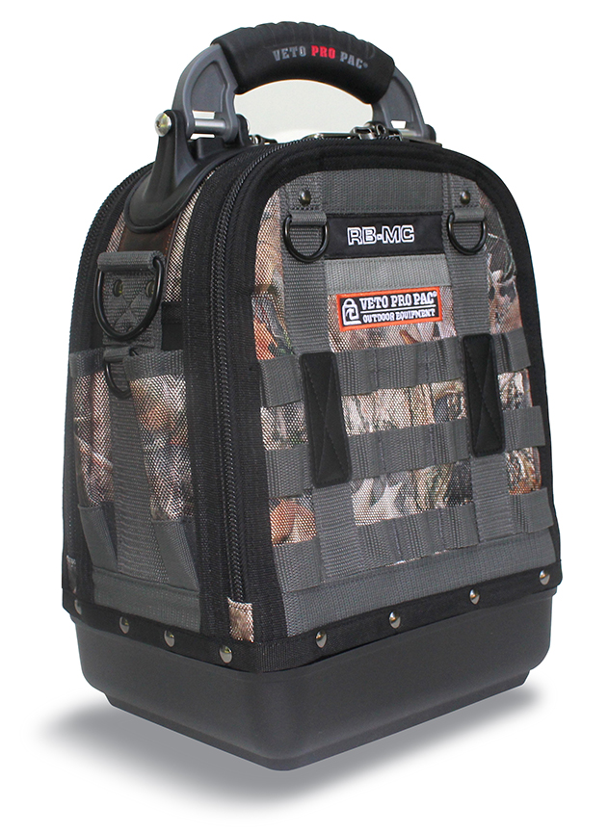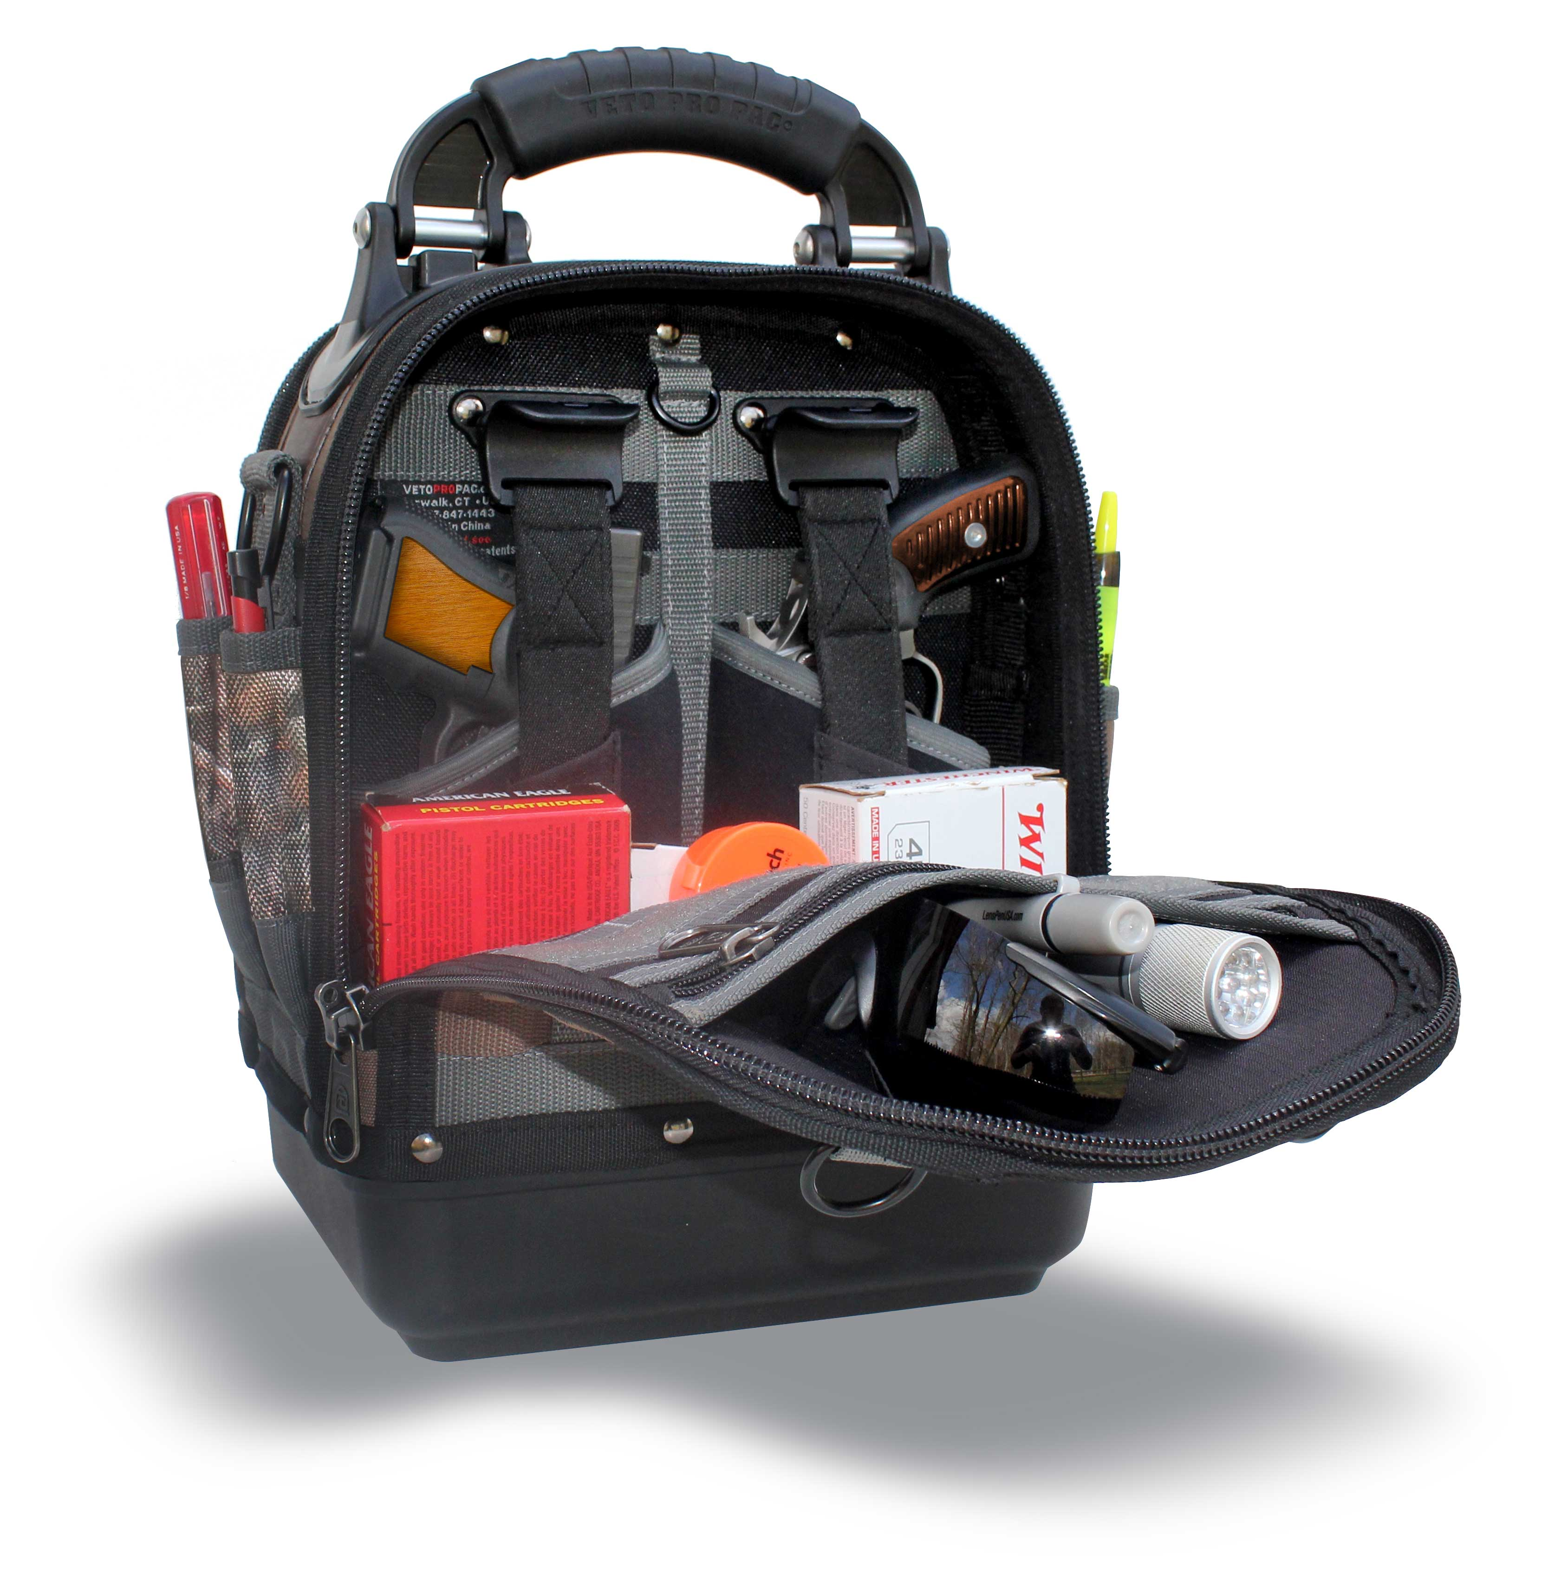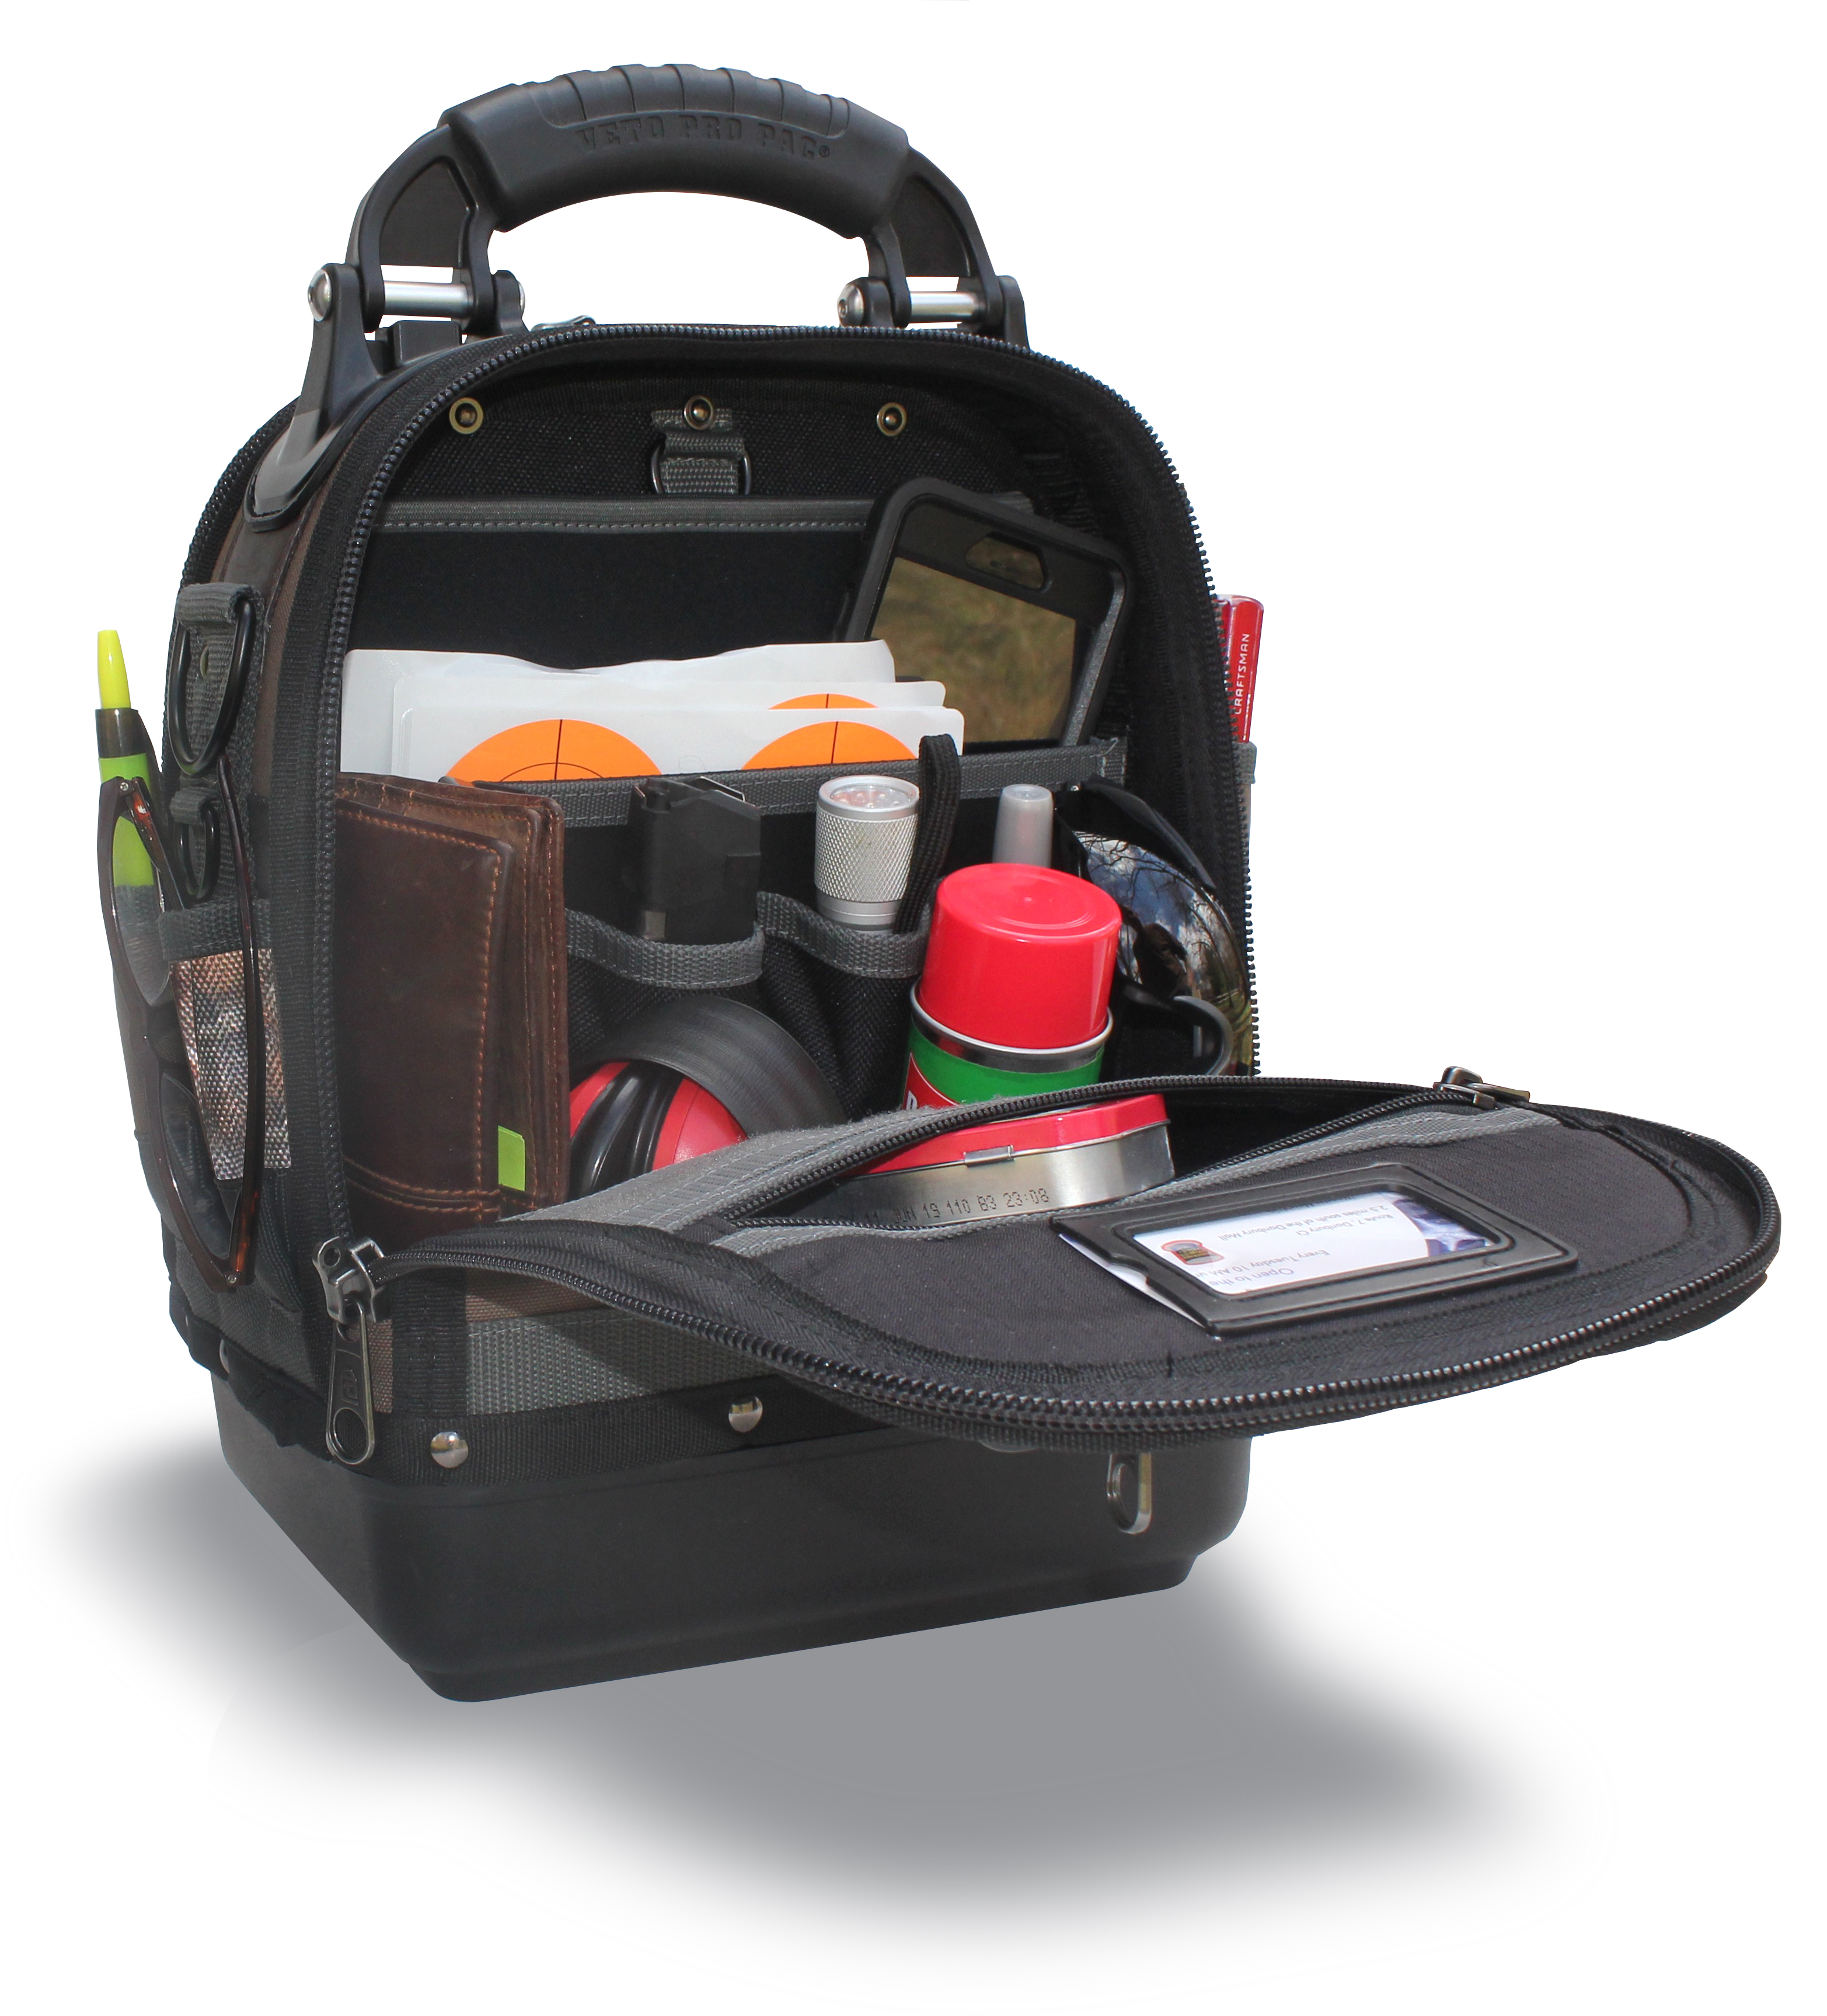

Norwalk, CT, January 2, 2019

Veto Pro Pac, the leading premium brand in the tool bag industry, launched its first compact, lockable Camo range bag, the Veto Pro Pac RB-MC CAMO TT, using the company’s patented center panel design, durable construction, injection molded base, vertical storage design, YKK ® locking zippers and TrueTimber ® Kanati Pattern. Through the company’s success with its tool bags that have redefined the tool bag industry, it has attracted a passionate customer base of professional tradesmen. Many of these professionals are avid shooting enthusiasts and have been asking the company to launch a line of range bags for years. These same customers were instrumental in helping develop the company’s first range bag as part of the company’s new “Camo and Outdoor Series”, which started with the launch in 2017 of Veto Pro Pac’s TrueTimber ® Camo products. In addition, the company will launch the RB-MC Camo MO, using Mossy Oak’s ® Break-Up Country Pattern in the summer of 2019. The company will also launch two Trapshooting bags with Mossy Oak’s ® Break-Up Country Pattern in the summer of 2019.

Roger Brouard, the company’s founder and product designer said, “With our signature plastic “hard bottom” bases, offering protection and stability, we received a ton of requests to use our bag design concepts for hand gun bags. With an injection molded bottom, vertical pocket orientation, technical grip and built in holsters with cobra clips, we developed a range/gun bag which offers a unique and functional platform that does not currently exist on the gun bag market today. Consequently, we are extremely excited about the opportunity to offer a new product line for the shooting range market and provide a unique product experience, in conjunction with TrueTimber ®, with the same Veto Pro Pac design concepts that allow better organization, a stable and durable waterproof base and enhanced visual inventory. The RB-MC Camo TT is a better way to store and carry all range related equipment”.

The Veto RB-MC CAMO TT range bag is feature rich and compact, standing at 14” high, 10” wide, and 8” deep, and offers expanded capacity and customizable storage options that allow customers to organize their range gear effectively and efficiently.

The outside design, with its Molle webbing, is built around Veto Pro Pac’s patented center panel design that offers weight loading through the center and vertical storage options on both sides of the bag. There are internally built holsters for two full sized handguns with foam blocks to support smaller guns, and an innovative Cobra Clip ® to secure the guns so that they can be removed easily with one finger. This configuration allows equipment and firearms to be stored vertically with the barrels of pistols pointing downward. The open space below the holsters offers ample storage for ammunition, and the neoprene and polyester pockets on the backside allows shooters to store magazines, safety glasses, ear protection, cleaning tools and more. The durable 3mm thick polypropylene base, a hallmark of Veto Pro Pac’s products, protects the bag from the elements and provides a stable platform to keep the bag vertical for good visibility and quick and easy access to all firearms equipment. In addition, Molle webbing is placed on the outside of the bag and on the inside flaps for even more storage options.

Some of the many features are:
- Integrated quick-draw compartment
- Water resistant 1600D polyester construction
- Quick-access admin panel
- Non-slip cross-body stabilizing strap
- MOLLE webbing to attach extra gear
- YKK® interlocking zippers
- Over molded handle
- 3MM polypropylene waterproof base
- Internal pockets to organize magazines and accessories
- 9 outer pockets for extra storage
- Outside velcro panel for swapping out patches
- Wide padded shoulder strap
- Designated ammunition box pockets
- Velcro space for patches

ABOUT VETO PRO PAC
Veto Pro Pac bags are professional grade, industrial strength soft-side tools, firearms and equipment storage and transportation configurations. Designed to protect and organize firearms, tools and equipment with vertical tiered pockets, tough 1200-1800 D polyester body fabric and plastic hard bottoms, Veto Pro Pac products work hard to deliver and support the level of functionality necessary in “real life” day to day use.

Having worked for 30 years as a carpenter from building wooden lobster boats to all levels of house repair and construction, Roger Brouard, the founder and designer of Veto Pro Pac’s tool and outdoor bags, makes sure that the Veto Pro Pac DNA of functionality is imbued in each product and up to the task, either in the field, on the job, or for outdoor recreational or sports use.

ABOUT TRUETIMBER ®

Strategically placed throughout the mixed hardwood and pine forest of Inman, South Carolina deer stands loom in the trees. It was from one of these quiet stands that our successful brand emerged in early 2005. TrueTimber’s founder and CEO, Rusty Sellars captured the ground beneath his deer stand on camera and brought the photo to his fabric mill for computer engraving and digital output. By capturing elements of brush, twigs, limbs, bark and leaves from their natural environment, a best-selling camouflage pattern was born. It was at that moment Rusty, his wife Paige and two sons; Hunter and Cody made a commitment to build a company dedicated to creating the industry’s most realistic camouflage patterns, using only the highest definition digital imagery available.
Over the course of the next 10 years, the Sellars family would build TrueTimber into a one stop shop for everything camouflage including; pattern design and licensing, textile printing, apparel wholesale and manufacturing, hydrographic film production, and even a retail store to sell products directly to local hunters.
Today, TrueTimber® products can be found in retailers across the United States and Canada. It continues to be one of the fastest growing camouflage companies in the world.

ABOUT MOSSY OAK ®

In 1986, Mossy Oak founder and CEO Toxey Haas had the vision to take a handful of Mississippi dirt, sticks and leaves and transform it into a brand new type of camouflage. Comprised entirely of natural earth elements and colors, the resulting design was unlike any pattern that had ever come before it, and gave hunters the power to obliterate their outline while effortlessly blending into the environment. Soon, our first industry-revolutionizing pattern, Mossy Oak Bottomland®, was born, and the distinguished Mossy Oak legacy had begun.
In the more than three decades since, advances in design technology including the incorporation of photorealistic 3D elements into our patterns have enabled us to fine-tune and perfect the art of hunting concealment. Highly effective and innovative patterns like Mossy Oak® Break-Up®, Break-Up Country®, Obsession®, Shadow Grass® Blades®, and Mountain Country®™ and new Mossy Oak® Elements®™ all utilize Mossy Oak’s industry-leading concealment technologies.
Through it all, we remain, at our humble roots, a company that creates patterns based exclusively on the natural environment — engineered, as always, for your ultimate success and enjoyment there.

Contact Information:
James Brooks
President
Jbrooks@vetopropac.com

