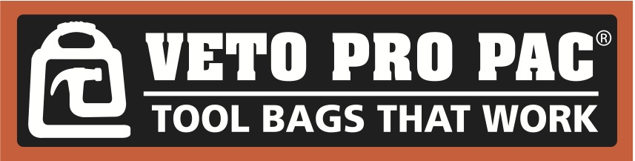

January 10, 2019

VETO PRO PAC WILL EXPAND ITS OUTDOOR SERIES WITH NEW MOSSY OAK ® BREAK UP COUNTRY PISTOL BAGS, TRAPSHOOTING BAGS AND TOOL/GEAR BAGS IN THE SUMMER OF 2019

Veto Pro Pac, the leading premium brand of tool bags, will launch a line of Mossy Oak ® products in the summer of 2019. Each of these products offers Mossy Oak ® Break-Up Country Pattern. Using dramatically larger limbs, leaves, bark, branches and other digitally enhanced natural elements, Mossy Oak Break-Up Country annihilates your outline and fuses you with the terrain like no pattern that has come before it – at any distance, anywhere across the country.

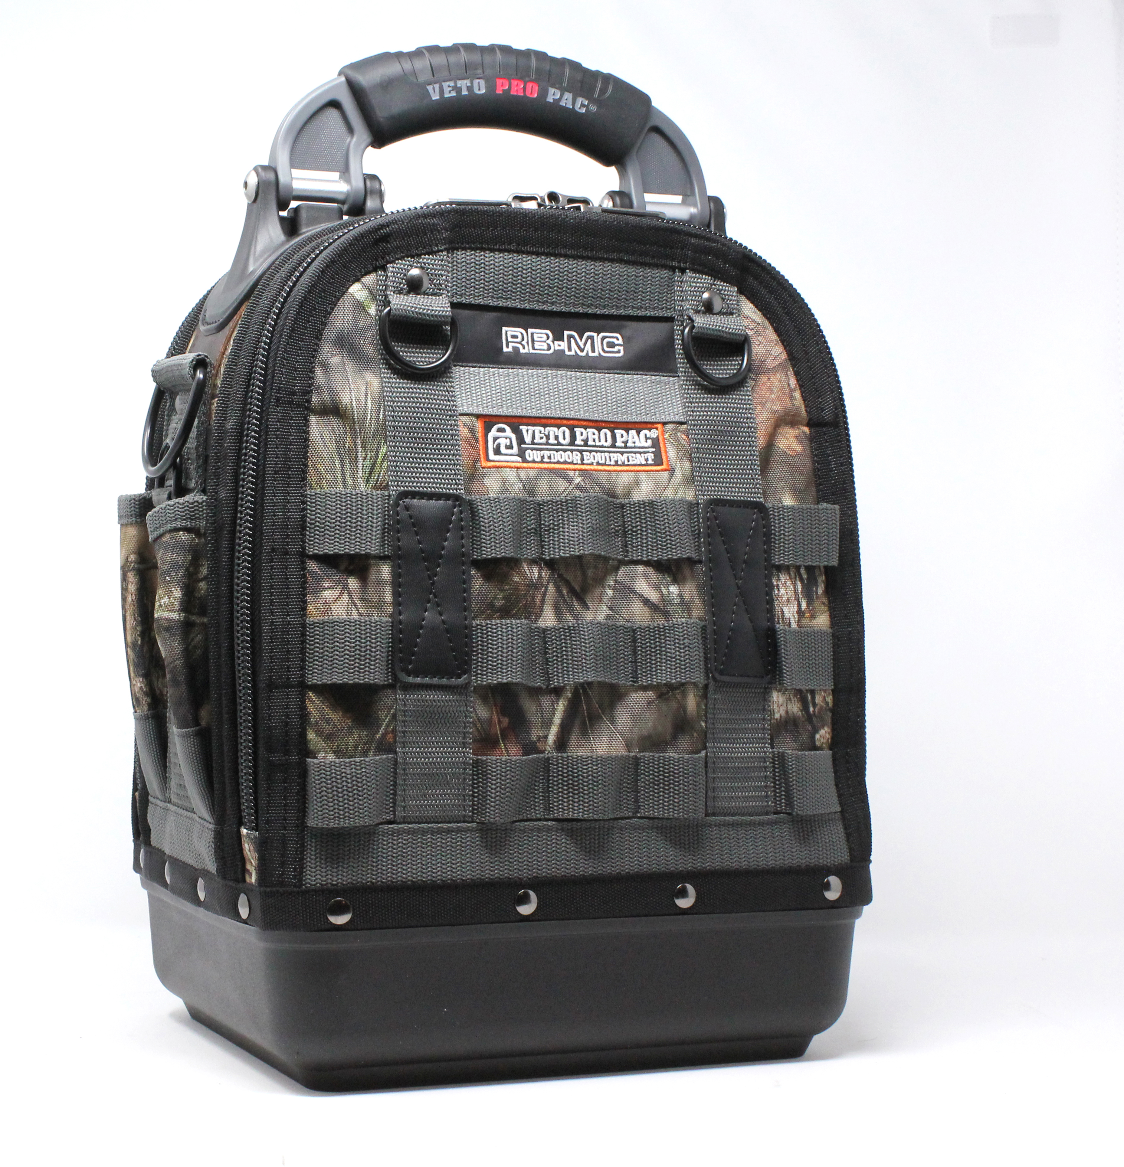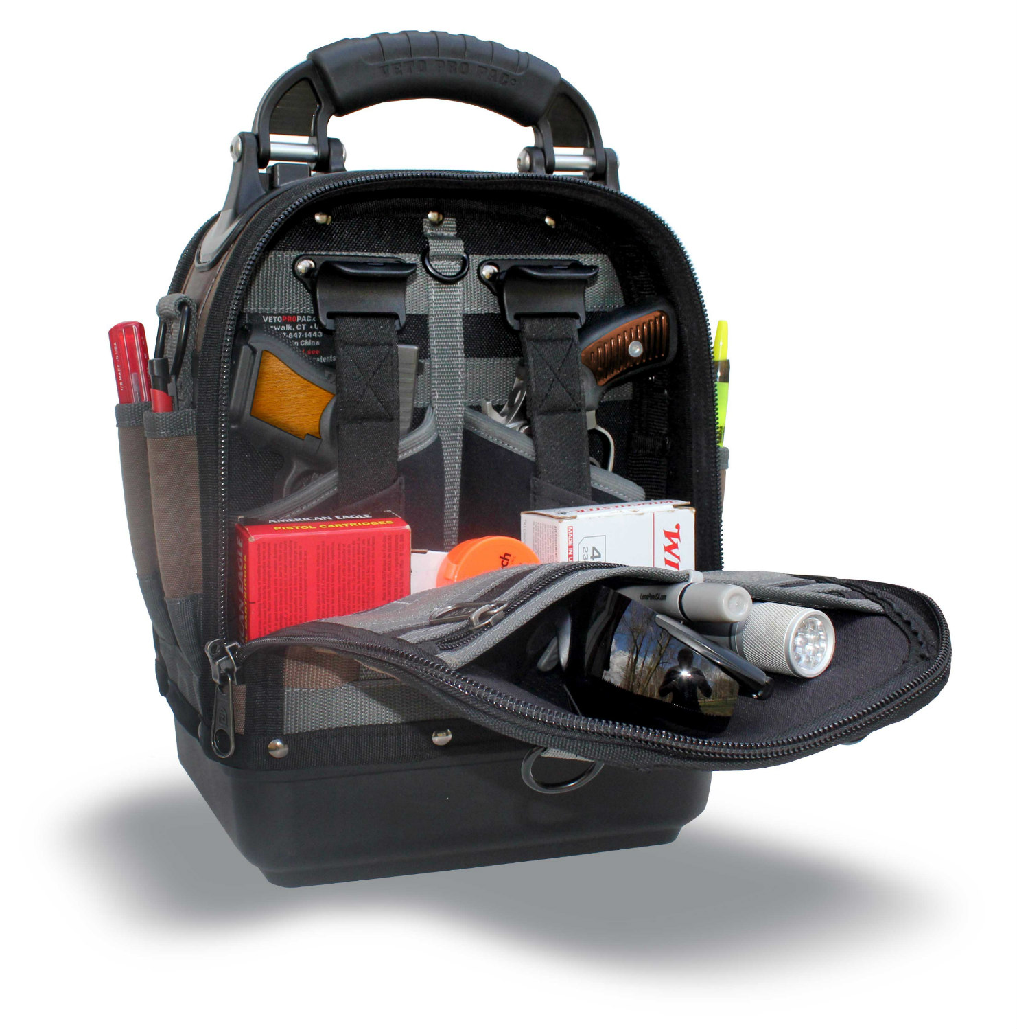

The RB-MC CAMO MO, will be a 2 pistol range bag using the company’s patented center panel design, durable construction, injection molded base, vertical storage design, YKK ® locking zippers and Mossy Oak ® Break-Up Country Pattern. Through the company’s success with its tool bags that have redefined the tool bag industry, it has attracted a passionate customer base of professional tradesmen. Many of these professionals are avid shooting enthusiasts and have been asking the company to launch a line of range bags for years. These same customers were instrumental in helping develop the company’s first range bag as part of the company’s new “Camo and Outdoor Series. In addition, the company will launch 2 Trapshooting bags, a backpack tool/gear bag, a compact tool bag, a tall gear pac, and a small cargo pac with Mossy Oak’s ® Break-Up Country Pattern in the summer of 2019.

The Veto RB-MC CAMO MO range bag is feature rich and compact, standing at 14” high, 10” wide, and 8” deep, and offers expanded capacity and customizable storage options that allow customers to organize their range gear effectively and efficiently.

The outside design, with its Molle webbing, is built around Veto Pro Pac’s patented center panel design that offers weight loading through the center and vertical storage options on both sides of the bag. There are internally built holsters for two full sized handguns with foam blocks to support smaller guns, and an innovative Cobra Clip ® to secure the guns so that they can be removed easily with one finger. This configuration allows equipment and firearms to be stored vertically with the barrels of pistols pointing downward. The open space below the holsters offers ample storage for ammunition, and the neoprene and polyester pockets on the backside allows shooters to store magazines, safety glasses, ear protection, cleaning tools and more. The durable 3mm thick polypropylene base, a hallmark of Veto Pro Pac’s products, protects the bag from the elements and provides a stable platform.

Veto Pro Pac’s Camo and Outdoor Series is the company’s newest series and part of a long line of high quality and functional products its customers have come to expect. The company has already redefined a market with industry leading innovation, unparalleled durability and design features that increase productivity on any job site.

Veto sells its products nationwide. To find a dealer in your area or to learn more about Veto’s Camo/Outdoor series visit: https://www.vetopropac.com/catalog/camo-series

ABOUT VETO PRO PAC
Veto Pro Pac bags are professional grade, industrial strength soft-side tools, firearms and equipment storage and transportation configurations. Designed to protect and organize firearms, tools and equipment with vertical tiered pockets, tough 1200-1800 D polyester body fabric and plastic hard bottoms, Veto Pro Pac products work hard to deliver and support the level of functionality necessary in “real life” day to day use.

ABOUT MOSSY OAK ®

In 1986, Mossy Oak founder and CEO Toxey Haas had the vision to take a handful of Mississippi dirt, sticks and leaves and transform it into a brand new type of camouflage. Comprised entirely of natural earth elements and colors, the resulting design was unlike any pattern that had ever come before it, and gave hunters the power to obliterate their outline while effortlessly blending into the environment. Soon, our first industry-revolutionizing pattern, Mossy Oak Bottomland®, was born, and the distinguished Mossy Oak legacy had begun.
In the more than three decades since, advances in design technology including the incorporation of photorealistic 3D elements into our patterns have enabled us to fine-tune and perfect the art of hunting concealment. Highly effective and innovative patterns like Mossy Oak® Break-Up®, Break-Up Country®, Obsession®, Shadow Grass® Blades®, and Mountain Country®™ and new Mossy Oak® Elements®™ all utilize Mossy Oak’s industry-leading concealment technologies.
Through it all, we remain, at our humble roots, a company that creates patterns based exclusively on the natural environment — engineered, as always, for your ultimate success and enjoyment there.

Contact Information:
James Brooks
President
Jbrooks@vetopropac.com

