1750 Brielle Ave. Unit B-1, Wanamassa, NJ 07712

FOR IMMEDIATE RELEASE

Bersa Announces New Pricing for 2019
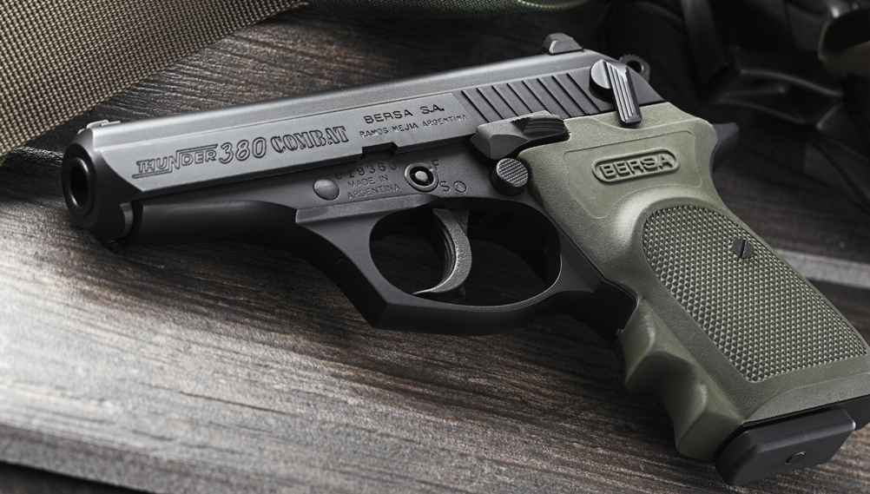
New pricing on Bersa line coincides with the #beginwithbersa marketing campaign recognizing that Bersa is the most popular choice for first-time firearm owners.

Wanamassa, NJ (December 2018) – Eagle Imports, Inc., the exclusive distributor of Bersa products, has announced new pricing for 2019. The new price positioning of the Bersa line includes all models in the popular Thunder and BP CC series of firearms.

“At Eagle, we are continually looking for new ways to improve our customer value and satisfaction,” Michael Sodini, president of Eagle Imports, Inc. said. “We periodically review our expenses and price lists to find ways to pass the savings on to the consumer.”

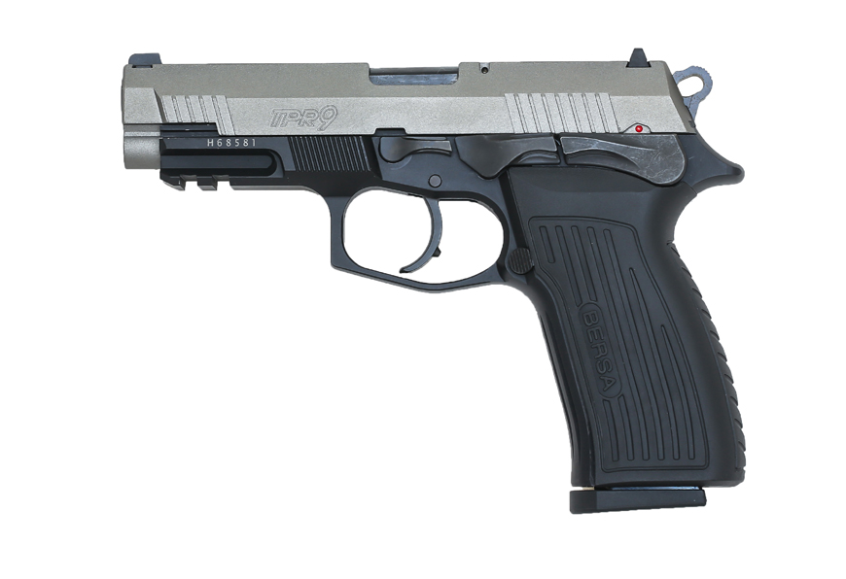
This price decrease also coincides with the announcement of the new #beginwithbersa campaign. Eagle Imports recognizes that many of their customers, in fact, started with a Bersa firearm and have continued to support the line ever since. This movement brings Bersa back to its roots, which included the launch of the Thunder 380, their flagship model. By adding the new price structure, Bersa brings back affordability to one of the most popular brands in the world. With this announcement, along with the recently introduced TPR line of pistols, Bersa and Eagle Imports plan to make a big splash in the firearms industry in 2019.

For more information about Bersa products visit www.bersa.com, For press inquiries contact Eagle Imports at info@bersa.com

Join the discussion on Facebook: facebook.com/BersaEaglelmports/ or lnstagram:
@bersa_usa
#beginwithbersa

About Bersa:
For over half a century Bersa has been manufacturing quality firearms and is known worldwide for reliability and attention to every ergonomic and functional detail. Boasting an excellent price­ performance ratio and using the most advanced technology concerning design, production, and quality control has helped make Bersa one of the most prestigious gun manufacturers in the world. Sportsmen and law enforcement worldwide enjoy the benefits and quality of Bersa. For more information, visit bersa.com.

About Eagle Imports Inc.:
Founded in 1988, Eagle Imports is proud of its history and tradition of being an exclusive firearms distributor in the United States. Eagle is committed to fulfilling Bersa, SPS, Metro Arms, Grand Power, and Avidity Arm's mission in the USA and for providing the ultimate after-sale experience for all of their products. Eagle Imports Inc. is proud to donate a dollar per every handgun sold to the Walk The Talk America movement that raises mental health awareness. www.eagleimportsinc.com

