Meprolight® USA
Middletown, PA 17057
P: (833) MEPROLIGT
(833) 637-7654
www.meprolight.us
FOR IMMEDIATE RELEASE

Visit Meprolight USA at the 2019 SHOT Show Booth #20043 and 15138

Meprolight® Announce US-based Division to Service North American Customers
Meprolight USA to provide US commercial, law enforcement and military customers with comprehensive customer service, product availability and strategic marketing in effort to grow brand and market share starting January 4, 2019.
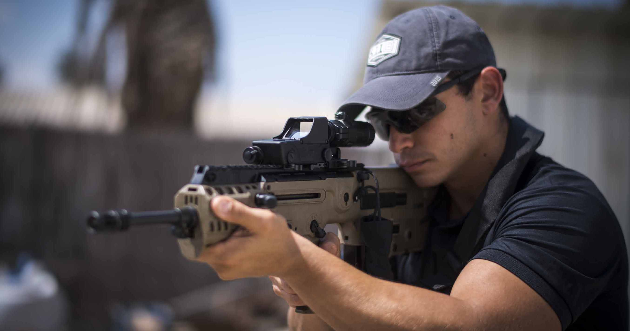

Middletown, Penn. (January 2019) - Meprolight®, a world leader in a variety of optic solutions from electro-optics sights, self-illuminated night sights, innovative pistol sights like the FT Bullseye, the R4E sights, and the Micro RDS, night vision and thermal devices, is proud to announce the opening of a new US-based facility to better serve their North American customers.
Meprolight USA will bring to their commercial, law enforcement, public service, security and military customers an unwavering commitment to providing responsive customer service, a large in-house supply of enhanced Meprolight products ready to ship and new marketing efforts to grow the brand in the US and develop a loyal market share.
As of January 4, 2019, the Meprolight USA sales team will be working directly with established distribution channels and partners, as well as reaching out to new customers for orders and sales inquiries. The investment in the North American market includes engaging marketing efforts to educate customers on the many benefits of this world optic leader’s products.
Meprolight USA will be launching at SHOT Show, January 22 – 25, 2019 in both booths - #15138 in the firearms section and their law enforcement booth # 20043. The new US sales team will be available for in-booth meetings to see the enhanced product line, new products.
Meprolight USA is resolved to being the number one source for optics solutions, providing customers with receptive customer service, innovative and game-changing products for commercial and law enforcement/military markets and engaging marketing support. Our vision is crystal clear.
For orders and sales inquiries, please contact: sales@meprolight.us, Phone number: (833) MEPROLIGT (833.637.7654)
For technical inquiries or technical support, please contact: support@meprolight.us

About Meprolight®:
Meprolight is a leading International Electro-Optics company, developing, manufacturing and marketing systems for infantry, armed forces, law enforcement agencies and civilian markets since 1990.
Meprolight provides comprehensive solutions with a wide array of combat-proven products; electro-optical solutions, night vision devices, digital Low light handheld devices, thermal target acquisition systems, and a variety of night sights and other tritium illuminated products for safety and security applications.
In 2019, Meprolight establishes a US division, Meprolight USA, to better serve their North American customers in the commercial, law enforcement, security and military markets. www.meprolight.us

