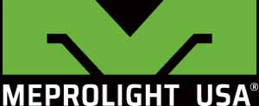
Meprolight USA®
Middletown, PA 17057
P: (833) MEPROLIGT
(833) 637-7654
www.meprolight.us
FOR IMMEDIATE RELEASE

Visit Meprolight USA® at the 2019 SHOT Show Booth #20043 and 15138

Meprolight USA® SHOT Show Debut;
Repositioning a New Leader in Optics Solutions for the US Market
Booth appearances and training segments by Instructor Zero of Team Zero, raffles and leading-edge new products on display will occur at both Meprolight USA® booths.
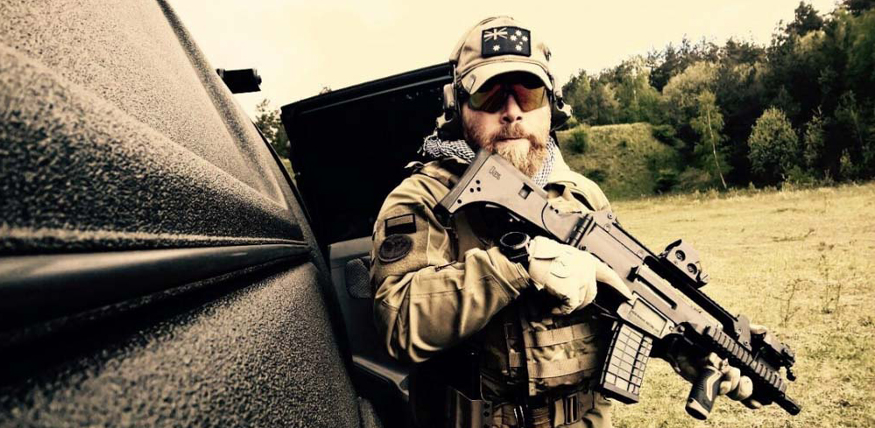

Middletown, Penn. (January 2019) - Meprolight USA®, a Subsidiary company of Meprolight®, a world leader in a variety of Electro-Optic, Thermal, and Night sights, will be hosting the international training specialist, Instructor Zero at Meprolight booths 20043 and 15138 during the 2019 SHOT Show in Las Vegas, Nevada.
On January 22nd and 23rd, Instructor Zero will bring his unique brand of training special operators to SHOT Show attendees. Besides offering his expertise, he will also demonstrate Meprolight USA’s new products, including the Mepro Foresight, the first-ever Augmented Reality reflex sight, the Mepro NYX-200, a multispectral thermal weapon sight, the all new Mepro HVS Night Sights and the Mepro MicroRDS pistol red dot and backup sight. Instructor Zero will stay on after his demonstration for a raffle announcement followed by poster signing and photo opportunities.
Instructor Zero, founder and CEO a Group of Companies under the name Team Zero Group, is a former Airborne Cp.l Instructor with expertise in firearms, strategy, security, risk analysis, and survival tactics. University Clinical Professor for 11 years in the Faculty of Science for Investigations and Security. His team provide training, strategic design, analysis, study and implementation of security protocols for high security clearance sites. Instructor Zero has worked with over 80 Special Units, including Special Forces and law enforcement from around the world.
Instructor Zero Booth Appearance Schedule:
Tuesday, January 22, 2019, Booth 15138
- 2 p.m. Instructor Zero training and new product demonstration
- 2:30 p.m. Instructor Zero announces raffle winner, poster signing and Instagram photo shoots until 3:30 p.m.
Tuesday, January 22, 2019, Booth 20043
- 3:30 p.m. Instructor Zero training and new product demonstration
- 4 p.m. Instructor Zero announces raffle winner, poster signing and Instagram photo shoots until 5 p.m.
Wednesday, January 23, 2019, Booth 15138
- 2 p.m. Instructor Zero training and new product demonstration
- 2:30 p.m. Instructor Zero announces raffle winner, poster signing and Instagram photo shoots until 3:30 p.m.
Wednesday, January 23, 2019, Booth 20043
- 3:30 p.m. Instructor Zero training and new product demonstration
- 4 p.m. Instructor Zero announces raffle winner, poster signing and Instagram photo shoots until 5 p.m.

Meprolight USA’s commitment to their US customers will be on full display with game-changing new optics and an all new HVS night sight family and new versions of the most popular Meprolight optical sights. Their US-based sales team will be present to firmly establish a solid and professional presence in the optic market. Current and former retailers will have access to knowledgeable and responsive sales staff. New retailers will find out why carrying the Meprolight USA brand builds customer loyalty and brings in profits.
Retailers can make appointments prior to SHOT Show. Please contact: sales@meprolight.us, Phone number: (833) MEPROLIGT (833.637.7654)
For technical inquiries or technical support, please contact: support@meprolight.us

About Meprolight®:
Meprolight is a leading International Electro-Optics company, developing, manufacturing and marketing systems for infantry, armed forces, law enforcement agencies and civilian markets since 1990.
Meprolight provides comprehensive solutions with a wide array of combat-proven products; electro-optical solutions, night vision devices, digital Low light handheld devices, thermal target acquisition systems, and a variety of night sights and other tritium illuminated products for safety and security applications.
In 2019, Meprolight establishes a US division, Meprolight USA, to better serve their North American customers in the commercial, law enforcement, security and military markets. www.meprolight.us
About Instructor Zero:
Founder and CEO a Group of Companies under the name Team Zero Group, Instructor Zero is a highly regarded, international training specialist for law enforcement and military agencies. The experienced and skilled team provide risk analysis and strategic solutions in different fields to government agencies and private companies in actually 27 country around the World. www.instructorzero.com

