Press information for immediate release
Tampa, FL – January 14, 2019

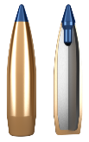
Norma Releases BONDSTRIKE Extreme – A New Line of Long-Range Hunting Ammunition

Norma® is pleased to introduce BONDSTRIKE™ Extreme – an all-new line of hunting ammunition designed from the ground up for extreme long-range accuracy and excellent performance on game at all distances. With a state-of-the-art polymer tip, proprietary bonding and a match-style boat tail projectile, BONDSTRIKE Extreme delivers an unmatched combination of long-range precision, penetration and terminal ballistics.

Norma’s engineers developed a unique bonding technology to maximize weight retention and ensure a devastating wound channel through controlled expansion at all velocities. Combined with the inherent accuracy of Norma’s sophisticated boat tail bullet design, BONDSTRIKE Extreme is the ideal cartridge for hunting whitetail deer, elk, antelope or any other medium to large-sized game.

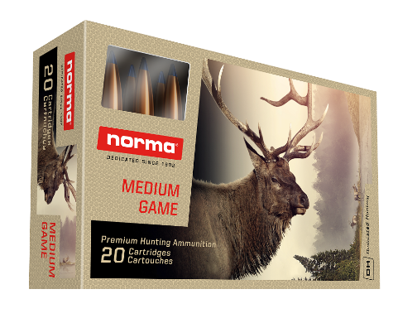
BONDSTRIKE Extreme will be on shelves in early 2019 and will be available in the following configurations:

- 308 Win 180gr BONDSTRIKE Extreme
- 30-06 180gr BONDSTRIKE Extreme
- 300 Win Mag 180gr BONDSTRIKE Extreme
- 300 WSM 180gr BONDSTRIKE Extreme
- 300 RUM 180gr BONDSTRIKE Extreme

“This is long range hunting at its best. Our engineers created a bullet that is bonded for weight retention and penetration—but gets excellent accuracy,” said Paul Lemke, General Manager for RUAG Ammotec USA. “The ballistic coefficient on this 30-caliber projectile is fantastic. From a performance standpoint, BONDSTRIKE Extreme will stand out from the crowded long-range hunting bullet market. With a variety of additional 30 caliber cartridges, big game hunters will reap the rewards of this long-range hunting ammunition come fall.”

Media contact: Tim Zick, Murray Road Agency
E-Mail: tim.zick@murrayroadagency.com

Norma is a registered trademark of RUAG Ammotec, a RUAG Group Company.

Established in 1902 and based out of Amotfors, Sweden, Norma has built a reputation world-wide for its dedication to quality, precision and reliability. Norma’s commitment to delivering trustworthy ammunition for hunters and shooters has been the driving
force in the continual growth and expansion of Norma’s product line-up and manufacturing capabilities. For more information on Norma ammunition and components, please visit Norma-usa.com.

Based in Tampa, Florida, RUAG Ammotec USA, Inc. is a division of Europe’s leading manufacturer of small arms ammunition and OEM components, RUAG Ammotec GmbH. RUAG Ammotec USA, Inc. not only introduces Swiss, German, Swedish and Hungarian hi-tech offerings to the U.S. marketplace, but also leverages European offerings known for precision, reliability and innovation and combines them with disruptive U.S. components, know-how and partnerships to manufacture and deliver world-class small arms ammunition solutions for use by sports shooters, law enforcers and warfighters in the United States and abroad. RUAG Ammotec markets commercial product offerings under the Norma, Geco, Swiss P and Inceptor brands.

RUAG Ammotec belongs to the Swiss technology corporation RUAG Holding AG, which is headquartered in Bern. RUAG develops and sells internationally renowned technology applications in the field of aerospace along with safety and defence technology for use on land, sea and in space. A total of 57% of RUAG's products and services are for civilian use, and 43% are intended for the military market. Its corporate headquarters are in Bern (Switzerland). Production sites are located in Switzerland and in 13 other countries in Europe, the USA, and the Asia-Pacific region. Around 8,700 employees – 430 of them trainees – represent 48 nationalities and generate revenue of around CHF 1.86 billion.

