Press information for immediate release
Tampa, FL – January 11, 2019

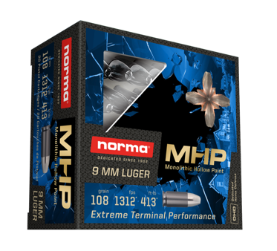
Norma Introduces Personal Defense Handgun Ammunition with New Monolithic Hollow Point (MHP)

For more than a century, Norma® has built a world-wide reputation among hunters for accuracy, reliability and terminal performance across a wide range of hunting applications. In 2019, Norma is proud to deliver this same standard of precision and ballistic performance with the release of its new 9mm Monolithic Hollow Point (MHP™).

Norma’s 9mm MHP is an all copper bullet with massive expansion and great stopping power. It is designed to reliably feed into all pistol and carbine chambers and is calibrated for consistent devastating terminal performance, regardless of barrel length. By achieving consistent, massive expansion, repeatable time-after-time, the Norma MHP is poised to set a new standard for personal defense ammunition.

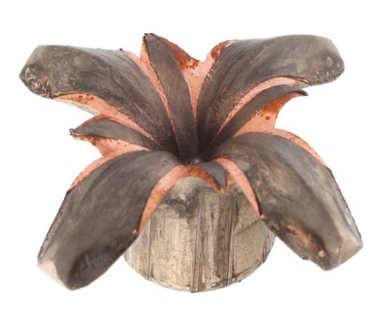
“Our new MHP is likely the most expanding 9mm bullet in the world,” said Paul Lemke, General Manager for RUAG Ammotec USA. “It also reliably feeds and performs with unmatched terminal affect through expansion, in all barrel lengths/firearm platforms. Getting this performance from an all-copper projectile is a very big accomplishment for our entire team. We’re proud to offer this unique personal protection and home defense option people can trust when it matters most.”

Initially being offered in 9mm with a 108gr projectile, the new MHP is the perfect choice for concealed carry and personal defense. Its cold formed monolithic copper construction delivers extreme terminal performance and consistent penetration out of any type of firearm or barrel length at varied velocities. MSRP for a 20-round box of Norma 9mm Luger MHP is $22.48.

Media contact: Tim Zick, Murray Road Agency
E-Mail: tim.zick@murrayroadagency.com

Norma is a registered trademark of RUAG Ammotec, a RUAG Group Company.

Established in 1902 and based out of Amotfors, Sweden, Norma has built a reputation world-wide for its dedication to quality, precision and reliability. Norma’s commitment to delivering trustworthy ammunition for hunters and shooters has been the driving
force in the continual growth and expansion of Norma’s product line-up and manufacturing capabilities. For more information on Norma ammunition and components, please visit Norma-usa.com.

Based in Tampa, Florida, RUAG Ammotec USA, Inc. is a division of Europe’s leading manufacturer of small arms ammunition and OEM components, RUAG Ammotec GmbH. RUAG Ammotec USA, Inc. not only introduces Swiss, German, Swedish and Hungarian hi-tech offerings to the U.S. marketplace, but also leverages European offerings known for precision, reliability and innovation and combines them with disruptive U.S. components, know-how and partnerships to manufacture and deliver world-class small arms ammunition solutions for use by sports shooters, law enforcers and warfighters in the United States and abroad. RUAG Ammotec markets commercial product offerings under the Norma, Geco, Swiss P and Inceptor brands.

RUAG Ammotec belongs to the Swiss technology corporation RUAG Holding AG, which is headquartered in Bern. RUAG develops and sells internationally renowned technology applications in the field of aerospace along with safety and defence technology for use on land, sea and in space. A total of 57% of RUAG's products and services are for civilian use, and 43% are intended for the military market. Its corporate headquarters are in Bern (Switzerland). Production sites are located in Switzerland and in 13 other countries in Europe, the USA, and the Asia-Pacific region. Around 8,700 employees – 430 of them trainees – represent 48 nationalities and generate revenue of around CHF 1.86 billion.

