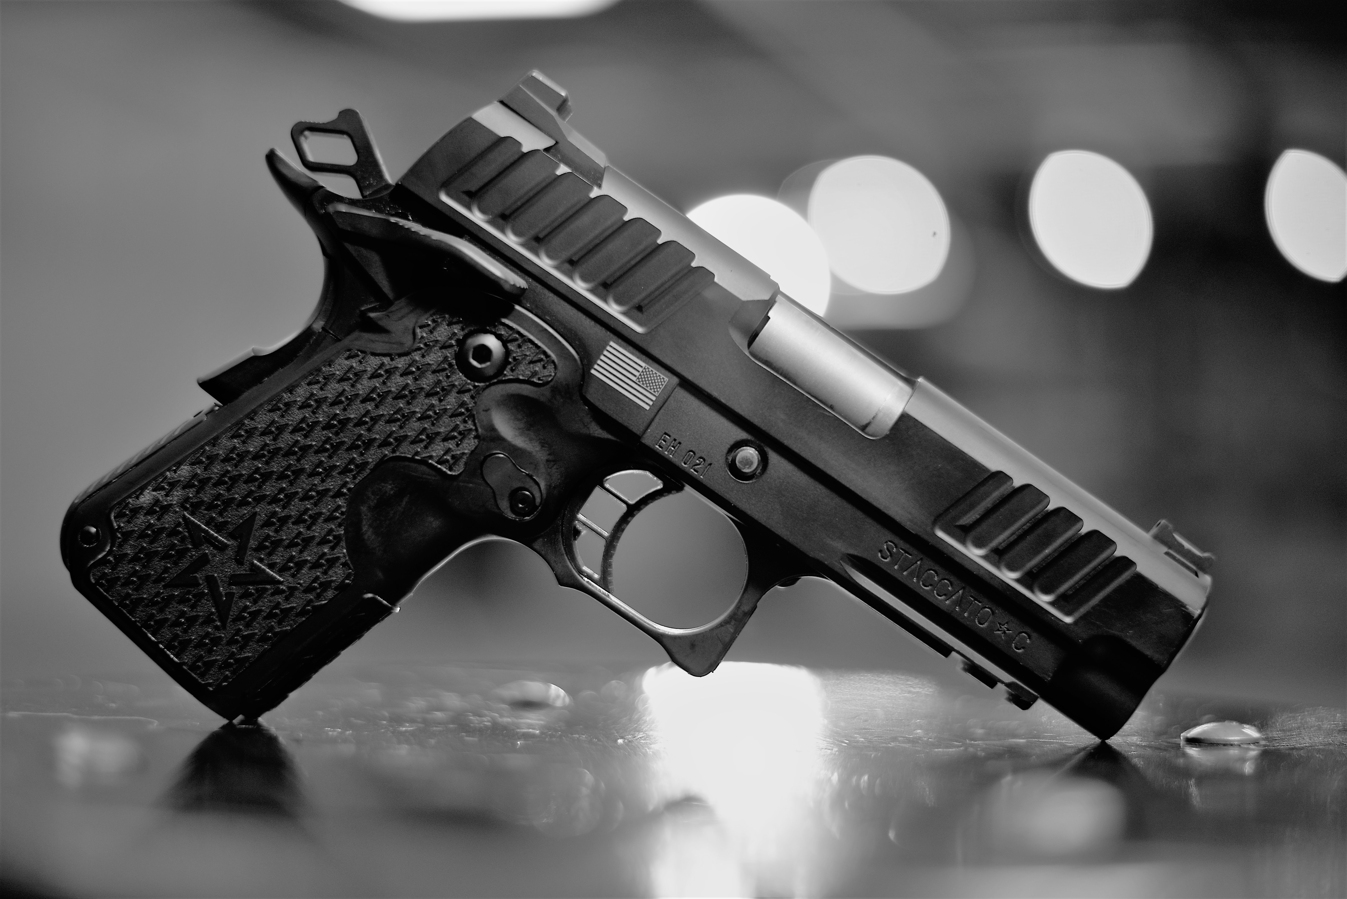
The Staccato- C
PERFORMANCE FEATURES
BARREL- 3.9 Bull, FINISH- Black Cerakote/ TRIGGER- 3.5 lbs Tactical Performance Trigger
SIGHTS- Fixed Ledge Rear Sight, Dawson Precision Fiber Optic Front Sight
GRIP- 2011 Single Stack Polymer Grip with Staccato Texture
Caliber- 9MM/ MAGAZINES- 2 Single Stack, 8 round magazines with Staccato Carry Basepads,
OTHER- Recoil Master Energy Transfer System, Bullet Groove Cocking Serrations, Integrated Magwell
The Staccato-C is a variation of our legendary design, the 2011®, in a single stack configuration that is perfect for concealed carry and personal defense. Our 2011® design was bred in the competition arena, dominating the action shooting sports for over 25 years because of our modular frame combined with a polymer grip that reduces recoil as well as reduces weight. The slim profile of the Staccato C incorporates FlaTec™, our flat shooting technology which combines proprietary design and craftsmanship, superior materials, and our recoil absorbing grip and 2011® frame. The result is less recoil transferred to the shooter leading to faster and more accurate shooting when it matters most. Dawson Precision fiber optic front sight and Fixed Tactical Rear, Stainless steel match grade bull barrel, bullet groove cocking serrations, ambi safeties, tactical performance trigger, integrated magwell, modular frame with tact rail combined with our Staccato textured polymer grip and undercut trigger guard are all a part of what makes the Staccato-C the World’s Best Shooting Carry Gun.
THERE IS NO FAIR FIGHT
Defend-Your family, your loved ones, and your life are the reason to choose the Staccato C
Protect-Stand vigilant with confidence; armed with the 2011® advantage
WIN-This is the most important gun you will ever own. Do not compromise, do not sacrifice, give yourself the unfair advantage and win…when it matters most

