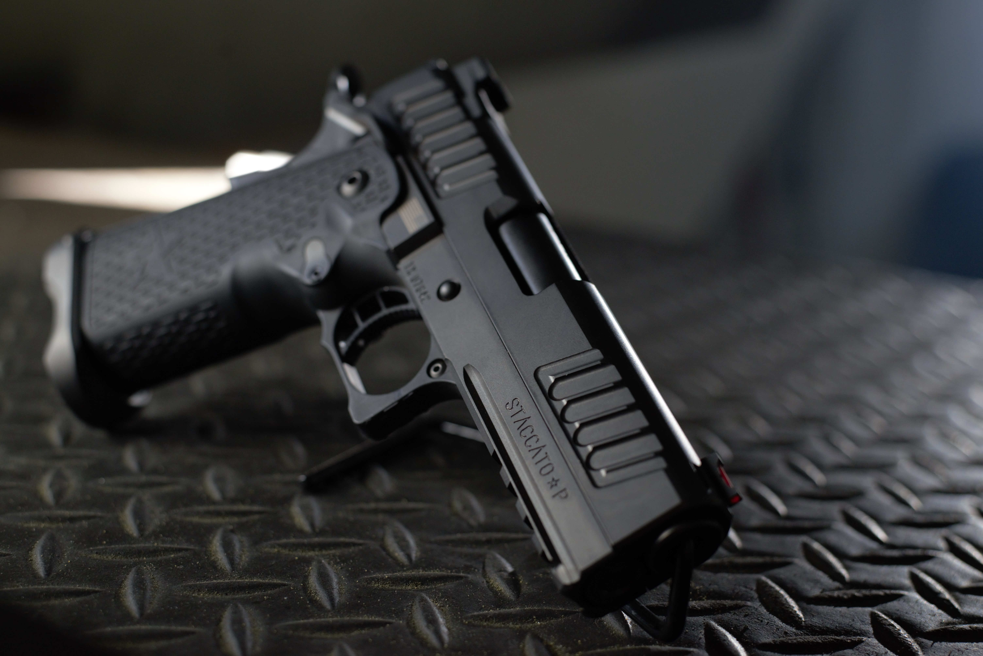
The Staccato- P
PERFORMANCE FEATURES
BARREL- 4.15 Match Grade Bull Barrel/ FINISH- Black Diamond Like Coating
TRIGGER- 3.5 lbs Tactical Performance Trigger/SIGHTS- Dawson Precision Charger Tactical Rear Sight, Dawson Precision Fiber Optic Front Sight/GRIP- 2011 Polymer grip with Staccato Texture and Undercut Trigger Guard
Caliber- 9MM/ MAGAZINES- 2 - 140mm, 20 round magazines
OTHER- Recoil Master Energy Transfer System, Bullet Groove Cocking Serrations, Operator Slim Magwell
The Staccato-P was designed with input from dozens of tactical and law enforcement professionals to create an agile, accurate, dependable and lethal platform that equips the user with the highest magazine capacity in the industry and the technology that has won thousands of World, National, Regional and state competitions in the hands of the BEST shooters in the World. The 4.15-inch barrel combined with the modular frame and integrated tact rail makes the Staccato-P agile in close quarters without sacrificing recoil mitigation. FlaTec™, our flat shooting technology which combines proprietary design and craftsmanship, superior materials, and our recoil absorbing grip and 2011® frame allows for faster follow up shots and increased accuracy in an operational environment when threats must be engaged and neutralized quickly without collateral damage. Dawson Precision fiber optic front sight and Charger Tactical Rear, Stainless steel match grade bull barrel, bullet groove cocking serrations, ambi safeties, tactical performance trigger, Operator Slim magwell, modular frame with tact rail combined with our Staccato textured polymer grip and undercut trigger guard are all a part of what makes the Staccato-P the World’s Best Shooting Duty Gun.
LETTING FREEDOM RING
Operate-Stand ready to face down the darkness with 2011®
Dominate- Enter the objective knowing you brought the best gun to the gunfight defending freedom
WIN- Your Country, your Team, and your community count on you. Give yourself every advantage. Be their guardian, their defender and win

