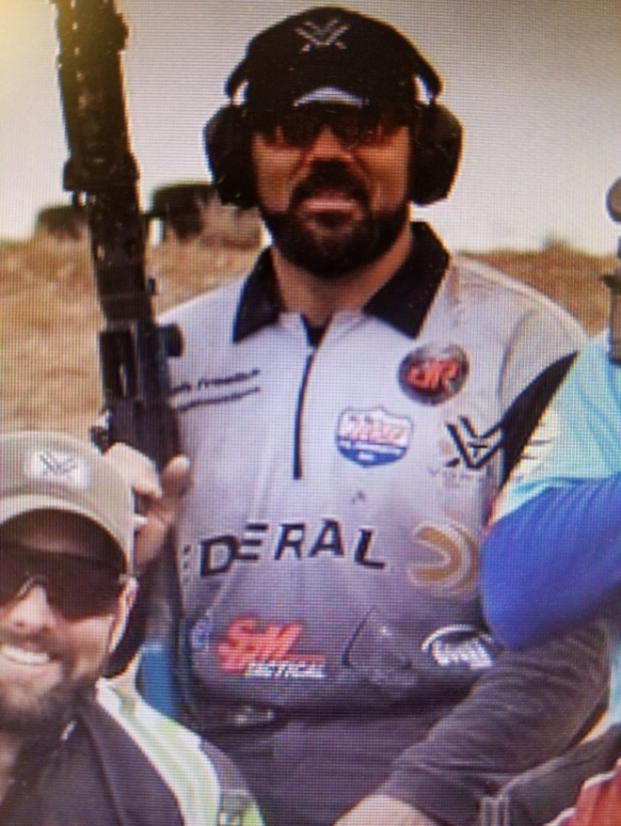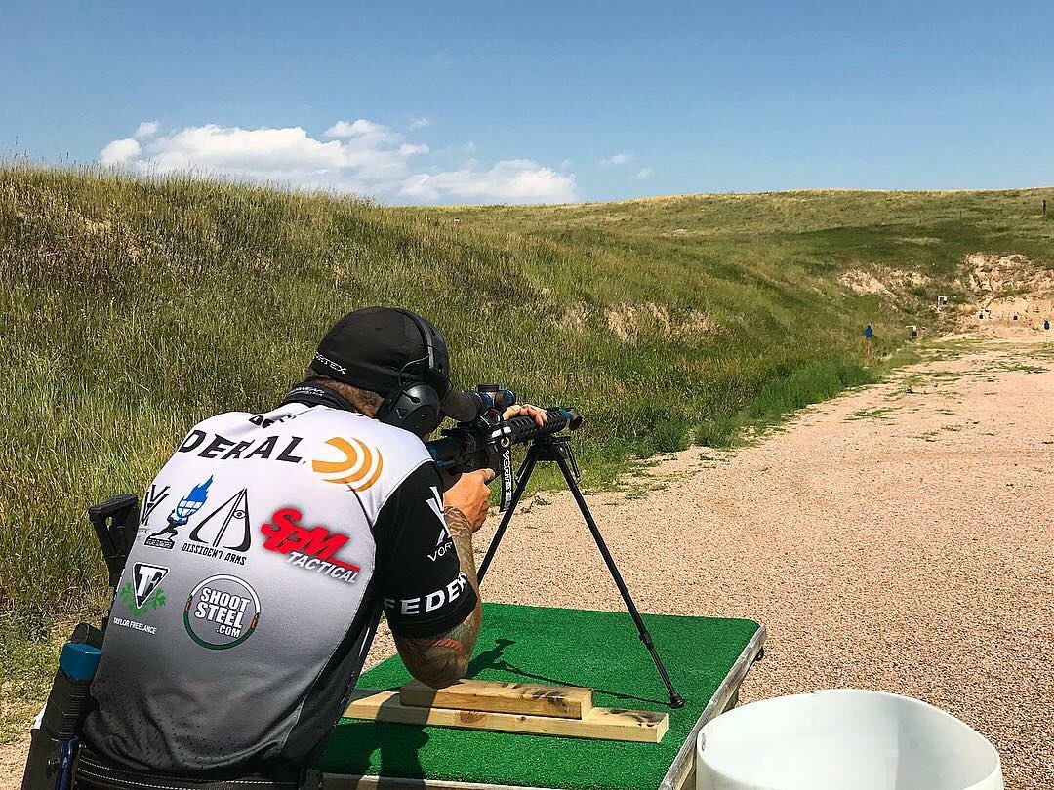
COME TO BOOTH #857 ON THURSDAY, JANUARY 25TH FROM 12:00 TO 1:00 PM AND MEET JOSH FROELICH!!!

*CURRENT IPSC SHOTGUN WORLD CHAMPION
*2 TIME – 3 GUN NATION NATIONAL CHAMPION
*HARD AS HELL MULTIGUN CHAMPION
*USA KALASHNIKOV “RED OCTOBER” CHAMPION
*2 TIME – NORDIC VORTEX TRI-GUN CHAMPION
*PURE GOLD SHOTGUN CHAMPION

