NEWS RELEASE
FOR IMMEDIATE RELEASE
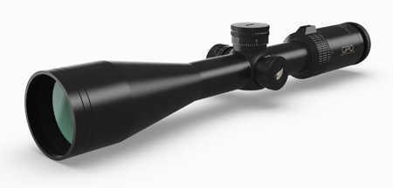
Passion 4X 6-24x50
German Precision Optics USA Introduces PassionTM 4X Riflescope Line

RICHMOND, Va. (Nov. 20, 2018) — German Precision Optics (GPO), USA has introduced the Passion 4X premium riflescope line. German designed and engineered, these scopes bring quality and value together in a scope line that offers higher magnification and large low-light objective lenses. The Passion 4x riflescopes are built on a 30 mm machined aluminum main tubes and are available in either 6-24x50 or 3-12x56.

The Passion 3-12x56 is available with or without the GPO proprietary iControlTM illumination on the G4 reticle. The G4i fiber-optic illumination technology system automatically powers down the illumination when the electronic module has been stationary for more than 3 hours and alerts the user when the battery has only 15 percent remaining life. The 3-12x56 is the perfect scope for low-light conditions. The new 6-24X50 30mm scope offers an excellent range of adjustment, a custom MOA ballistic reticle and a custom Kenton turret made for your favorite caliber, making it the perfect scope for long-range shooting.

For optimum light transmission, both riflescopes feature double HD glass and the proprietary GPOBrightTM lens-coating technology. Second focal-plane scopes, the Passion 4x line reticles will remain the same size throughout all magnifications. Additionally, the solid, one-piece dust-proof, waterproof, nitrogen-filled riflescope bodies offer constant point of impact and the ultimate in strength and durability. All GPO products purchased in the USA include the GPO, USA’s Spectacular Lifetime WarrantyTM. Full details of this warranty can be found at www.gpo-usa.com.

About GPO USA
German Precision Optics was founded on the premise that design, engineering and quality management is 100 percent controlled in Germany to its strictest standards, yet products can be produced at some of the largest production facilities around the world. This unique corporate structure allows GPO to offer the highest quality products with better features at a significantly better price. The company is 100% confident that all of its products will not only function perfectly but will exceed all expectations. Therefore, GPO, USA has created an industry-leading Spectacular Lifetime Warranty™. With outstanding professional service, GPO USA will take care of its products before, during, and after the purchase at no charge - EVER. Founded in 2016, GPO has it US headquarters in Richmond, Va. For more information on GPO US visit www.gpo-usa.com or call 844-MY BINOS (844-692-4667.)

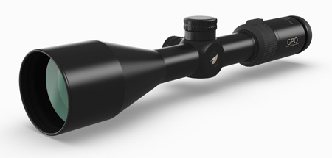
Passion 4X 3-12x56

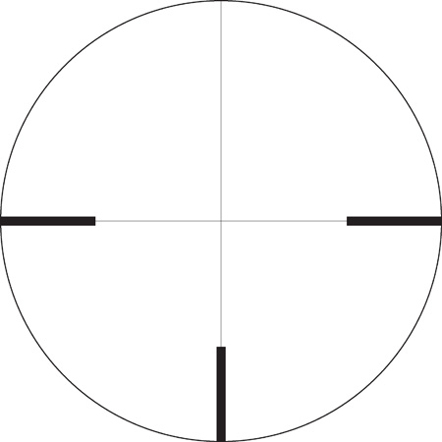
G4 Reticle
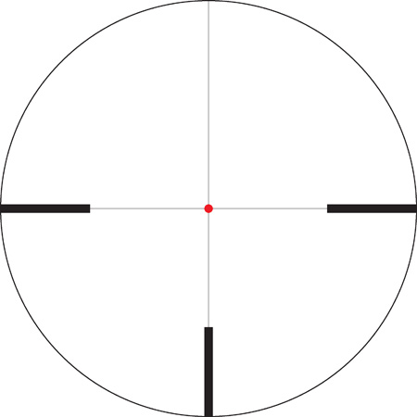
G4i Illuminated Reticle
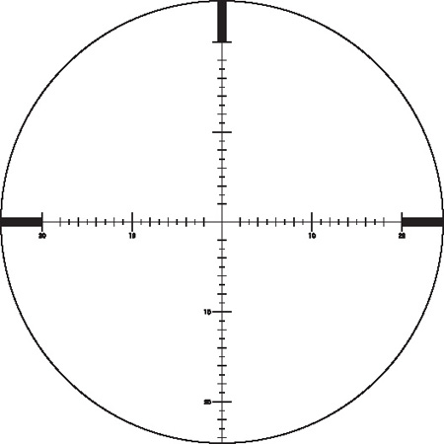
MOA Reticle

GPO RIFLESCOPE TECHNICAL SPECIFICATIONS |  |  | PASSION 4X |  | PASSION 4X |  | PASSION 4X
Optical parameter | Description | Value | 3-12x56 |  | 3-12x56i |  | 6-24x50
 |  |  | Min | Max | Min | Max | Min | Max
Magnification |  |  | 3x | 12x | 3x | 12x | 6x | 24x
Field of View (FOV) |  | ft/100y | 37 | 14 | 37 | 14 | 17 | 5
Field of View (FOV) |  | m/100m | 12.2 | 4.6 | 12.2 | 4.6 | 5.5 | 1.5
Objective diameter | Effective diameter | mm | 56 |  | 56 |  | 50
Exit pupil diameter | Measurement of the pupillary ocular beam | mm | 18.7 | 4.7 | 18.7 | 4.7 | 8.3 | 2.1
Eye Relief | From the last optical surface | inches | 3.5 |  | 3.5 |  | 4
Eye Relief | From the last optical surface | mm | 90 |  | 90 |  | 100
Focal plane | F2 - non-magnifying reticle  F1 - magnifying reticle |  | F2 |  | F2 |  | F2
Travel value per click | 1 Click = x / 100y | inches | .36" |  | .36" |  | .25" (1/4")
Travel value per click | 1 Click = x / 100m | cm | 1 |  | 1 |  | 0.63
Elevation range total | 100y | inches | 52 |  | 52 |  | 70
Elevation range total | 100m | cm | 145 |  | 145 |  | 190
Windage range total | 100y | inches | 52 |  | 52 |  | 51
Windage range total | 100m | cm | 145 |  | 145 |  | 140
Parallax compensation | Parallax free at x distance |  | 100m |  | 100m |  | 25yds to infinity
Transmission Daylight | ISO 14490-5:2005 |  | 90.00% |  | 90.00% |  | 90.00%
Height | Without covers | inches | 1.9 |  | 1.9 |  | 2.6
Height | Without covers | mm | 49.3 |  | 49.3 |  | 66.3
Width | Without covers | inches | 2.8 |  | 3 |  | 3.2
Width | Without covers | mm | 72 |  | 75 |  | 82.5
Length | Measured at outside diameter | inches | 13.4 |  | 13.4 |  | 15.4
Length | Measured at outside diameter | mm | 340 |  | 340 |  | 390
Tube diameter | Width of main tube | inch or mm | 30 |  | 30 |  | 30
Mechanical outer diameter | Objective end of scope | mm | 68 |  | 68 |  | 58
Mechanical outer diameter | Ocular end of scope | mm | 43 |  | 43 |  | 43
Weight | Without covers | ounces | 22.6 |  | 23.3 |  | 27.2
Weight | Without covers | grams | 640 |  | 660 |  | 770
Turrets | Type |  | PassionTrac |  | PassionTrac |  | MOA target
Reticle Options | G4 = German #4  G4i = German #4 illuminated  HS(i) = Horseshoe illuminated |  | G4 |  | G4i |  | MOA

Editorial Contact:
Karen Lutto (830) 755-4308
karen@hunteroc.com
Mike Nischalke (703) 380-3595
mike@hunteroc.com
HOC Website: www.hunteroc.com

