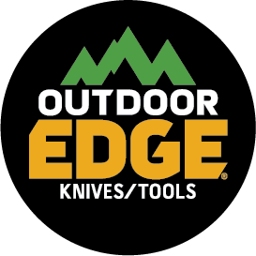
NEWS RELEASE
FOR IMMEDIATE RELEASE

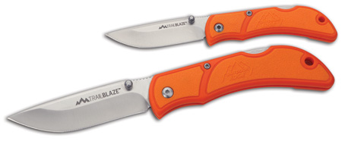
The TrailBlaze is the New Drop-Point Folding Knife from Outdoor Edge®

DENVER (January 10, 2019) — Versatile and easy to carry, the new TrailBlaze™ drop-point folding knife from Outdoor Edge is a fully capable hunting knife that is also conveniently suited for everyday carry. Available in either a 2.5- or a 3.3-inch blade length, the new TrailBlaze features ambidextrous thumb studs for easy one-hand opening as well as a stainless-steel pocket clip for easy sheath-free carry.

Outdoor Edge designed the TrailBlaze handle to be both extremely durable and ergonomic. With its orange glass/nylon polymer handle and molded thermoplastic rubber (TPR) inserts, the knife is instantly comfortable in the hand. It affords confidence and a non-slip grip when field dressing game, working in camp or on a job site. Made of Japanese stainless steel that is precisely heat-treated and hand finished to be shaving sharp, the TrailBlaze blade offers superior edge retention and performance.

The new TrailBlaze will be available this Spring for a suggested retail price of $20.95 for the 2.5-inch version and $26.95 for the 3.3-inch knife. Be sure to pick one up for your next hunting, fishing, camping or everyday adventure.

About Outdoor Edge
Founded in 1988 and headquartered in Denver, Outdoor Edge is a leading designer and manufacturer of knives and tools. Today, Outdoor Edge continues to innovate and develop state-of-the-art products for outdoor enthusiasts, game processors, survivalists, handymen and others who require the very best knives and tools available for leisure, work and everyday-carry needs. The company prides itself in offering a variety of products that undergo extensive field-testing in harsh, rugged environments resulting in durable, long-lasting products that come with a lifetime guarantee. For additional information on Outdoor Edge and its full line of products write to: Outdoor Edge, 5000 Osage Street, Suite 800, Denver, CO 80221; call toll-free 800-477-3343; email moreinfo@outdooredge.com; or visit www.outdooredge.com.

TrailBlaze Specs
Blade: 2.5 or 3.3 ins.
Overall length: 5.75 or 7.5 ins.
Steel: 8Cr13MoV
Handle: Glass/Nylon polymer with TPR inserts
Weight: 1.2 or 2.6 oz.

Editorial Contact:
Karen Lutto (830) 755-4308
karen@hunteroc.com
Mike Nischalke (703) 380-3595
mike@hunteroc.com
HOC Website: www.hunteroc.com

Be sure to visit Outdoor Edge at ATA booth #1539 and SHOT Show booth #1220.

