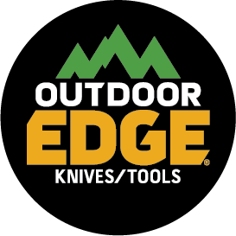
NEWS RELEASE
FOR IMMEDIATE RELEASE
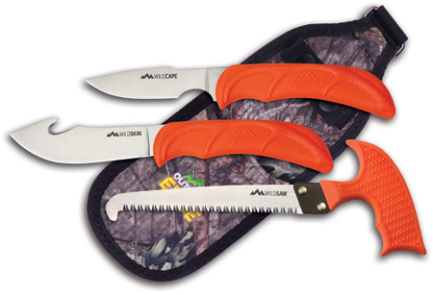
Outdoor Edge® WildGuideTM is the Perfect Hunting Combo

DENVER (Jan. 10, 2019) —Outdoor Edge absolutely simplifies the hunting-knife-selection process with the introduction of its new WildGuide combo set. The set is comprised of a caping knife, a gut-hook skinner and a T-handle wood/bone saw, which all fit neatly into a custom nylon sheath. The WildGuide set is the perfect hunting combo to break down big game harvests.

The caper has a 2.5-inch, 420J2 stainless-steel caping blade that allows it to endure more stress while maintaining superior edge retention. The gut-hook skinner has a 4-inch stainless steel, shaving-sharp blade and is very well balanced. The saw is a T-handled wood or bone saw that has a 4.9-inch 65Mn steel blade with triple-ground saw teeth and a chrome coating for long-lasting performance.

All three tools in the WildGuide set feature glass-reinforced nylon handles with blaze-orange thermoplastic rubber overmolding. The knives are full tang. The nylon belt sheath is covered in Mossy Oak® camouflage.

The WildGuide set will be available this spring at retailers nationwide or conveniently online at www.outdooredge.com for a suggested retail price of $47.95.

About Outdoor Edge
Founded in 1988 and headquartered in Denver, Outdoor Edge is a leading designer and manufacturer of knives and tools. Today, Outdoor Edge continues to innovate and develop state-of-the-art products for outdoor enthusiasts, game processors, survivalists, handymen and others who require the very best knives and tools available for leisure, work and everyday-carry needs. The company prides itself in offering a variety of products that undergo extensive field-testing in harsh, rugged environments resulting in durable, long-lasting products that come with a lifetime guarantee. For additional information on Outdoor Edge and its full line of products write to: Outdoor Edge, 5000 Osage Street, Suite 800, Denver, CO 80221; call toll-free 800-477-3343; email moreinfo@outdooredge.com; or visit www.outdooredge.com.

WildGuide Specs
Caping blade: 2.5 in
Overall: 8.3 in

Skinner blade: 4.0 in
Overall: 8.5 in

Saw Blade: 4.9 in
Overall: 8.0 in

Weight: 11.4 oz

Editorial Contact:
Karen Lutto (830) 755-4308
karen@hunteroc.com
Mike Nischalke (703) 380-3595
mike@hunteroc.com
HOC Website: www.hunteroc.com

Be sure to visit Outdoor Edge at ATA booth #1539 and SHOT Show booth #1220.

