Press Release Jan 22 – 25, 2019
RWA
Shot Show 2019 Invitation

2019 is the 20th anniversary of RedWolf Airsoft. Thank you for your continuous support over the years! We have been providing great airsoft products from different brands as well as developing hot products such as Agency Arms series, Nighthawk Custom series and etc.

This year, 2019, in order to celebrate RWA 20th anniversary, we proudly present 3 major releases including, (a) new Battle Arms Development Rifle which features on both AEG and GBB system, (b) Nighthawk Custom War Hawk that utilise the Tokyo Marui 1911 system that is powered by both green gas and CO2, (c) Agency Arms Agent 2 GBB Pistol, and (d) a new partnership with Hillbilly 223 Cerakote.

BAD Rifles:
RWA finally introduces the long awaited collaboration with Battle Arms Development, NV (USA) and Fortis Manufacturing (USA) with their 556-LW GBBR which will be running on a formidable Tokyo Marui M4 MWS GBB ZET system. Fully constructed from CNC billet Aluminum, the 556-LW is a sleek, lightweight, compact and handsome piece of equipment.

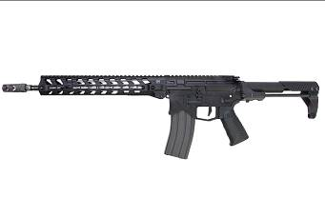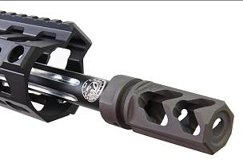
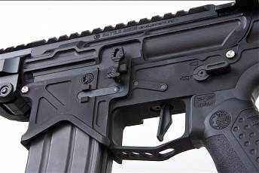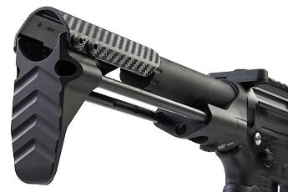

Nighthawk Custom War Hawk:
The Nighthawk Custom War Hawk is a unique 1911 that stands out amongst the competition. At first glance, you will be taken back by its striking tri-cut slide design giving it an aggressive look. In addition to the slide sporting the head turning tri-cut, it also has prominent serrations both up front and at the back for firm grip when racking the slide. Finally, there are top serrations that come to an arrow point right behind the red fiber optic front sight helping the shooter track targets easier.
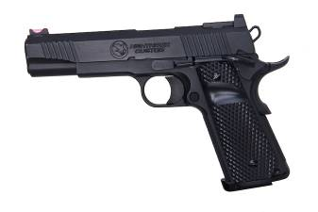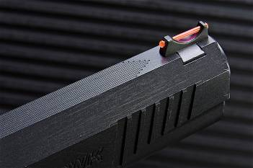
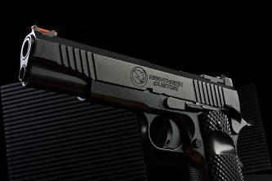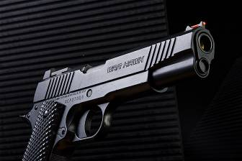
Agent 2:
The RWA licensed airsoft version is a faithful replication and pays homage to the afore mentioned real steel counter part. For starters, the gun is made from 3D blueprints provided by Nighthawk Custom and Agency Arms themselves for maximum authenticity. Having the blueprints allows the slide, grip, and frame to all be made using CNC with aluminum. In addition to all this, the outer barrel is stainless steel. Tying all of this together it also features a cerakote coating identical as its real steel counterpart seen exquisitely done by Hillbilly 223.

Internally the gun packs a system and parts worthy of its externals. The RWA Agent 2 takes full advantage of the tired and proven Tokyo Marui 1911 system that is renown for being consistent and extremely gas efficient. Being a pistol based of the TM 1911 system, the gun is compatible with any green gas magazine that can work with said system. Meaning, this gun opens up a world of options for the user when it comes to choosing the magazines best suited for you.
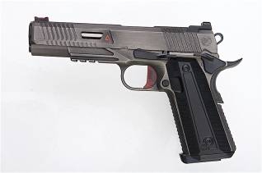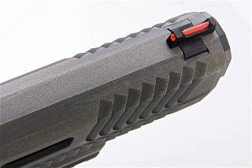
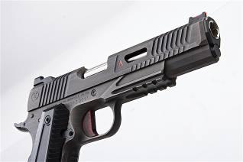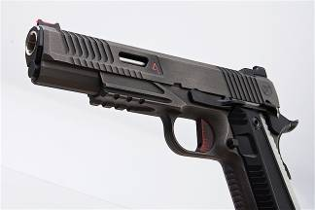
Hillbilly 223 Airsoft Coating Center:
Hillbilly 223 is a leader in the industry with top of the line high quality custom Cerakote finishes. As a dealer and manufacturing-based company, he focuses on firearm Cerakote coatings. He has also cooperated with Nighthawk Custom, Battle Arms Development and Nemo Arms etc with skills that popular in the industry.

We are proud to announce our collaboration with him and the release of Worldwide Hillbilly 223 Airsoft Coating Center, providing firearm Cerakote service to our airsoft products! Raising the standard of any airsoft products via unique, tailor made coating on each one of them!

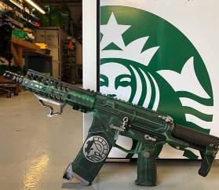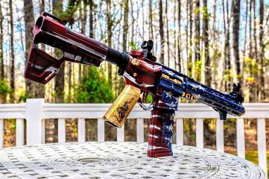
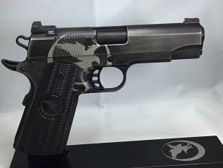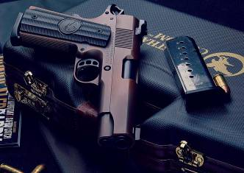

We will be at booth #6310 at SHOT Show 2019 from Jan 22 - 25. We hope you can visit us during this period, and we would love to introduce all these new products and service to you personally!

We look forward to seeing you there!

Date: Jan 22 - 25 2019
Time:
Tue Jan 22:
8:30AM - 5:30PM

Wed Jan 23:
8:30AM - 5:30PM

Thu Jan 24:
8:30AM - 5:30PM

Fri Jan 25:
8:30AM - 4:00PM

Location: Sands Expo Center | Las Vegas, Nevada
Booth: #6310

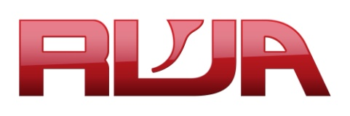
Website: http://www.rwa-group.com/
Facebook: https://www.facebook.com/rwagrp/?ref=br_rs
Instagram: https://www.instagram.com/rwagroup/

