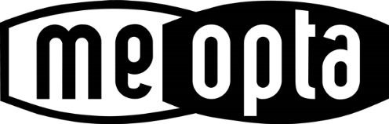

FOR IMMEDIATE RELEASE

Meopta USA Introduces New Dichroic Reticle Technology
with Battery-Free Illumination

TAMPA, FL, January 14, 2019 – Meopta USA is now offering groundbreaking new dichroic reticle technology in its MeoStar 3-12x56 riflescopes. Meopta’s patent-pending dichroic DichroTech coating enables reticles in multiple color configurations to automatically adjust color tone and intensity in varying light conditions without the use of a battery. DichroTech provides maximum contrast and visibility, enhancing target acquisition while speeding and improving shot placement.
Meopta’s first DichroTech reticle with battery-free, color-contrast enhancement, the 4D DichroTech, features a 4 MOA red dot in the center of the reticle. The dot and crosshairs are activated by ambient light for enhanced target acquisition. The proprietary patent-pending, light-sensitive dichroic coating appears bright red in daylight conditions but in lower light, depending on the background, the red may change to a light green color for better contrast. The reticle color adapts for optimal visibility depending on the amount of available ambient light while the dot in the center draws the eye to the point of aim. In addition, unlike the standard black reticle, the colored reticle is mostly transparent, which allows for a more complete field of view, particularly at higher magnifications.
“We are excited to bring this exceptional reticle technology to the hunting and shooting communities,” said Randy Garrison, Director of Meopta USA Sport Optics. “Meopta DichroTech reticles feature a leading-edge coating that enhances contrast and improves aiming ability in varying light conditions. This reticle technology offers hunters and shooters a convenient alternative to battery-powered illuminated riflescopes.”
The Meopta DichroTech 4D reticle is designed for maximum visibility in varying light conditions; with ambient light it provides significant target contrast at dawn, dusk, and throughout the day.

Initially, the Meopta DichroTech 4D reticle will be offered in the 30mm MeoStar R1 3-12x56 with a first focal plane reticle, and MeoStar R1r 3-12x56 with a second focal plane reticle. Meopta will offer many more DichroTech reticle options in a variety of riflescopes in 2019.

-more-

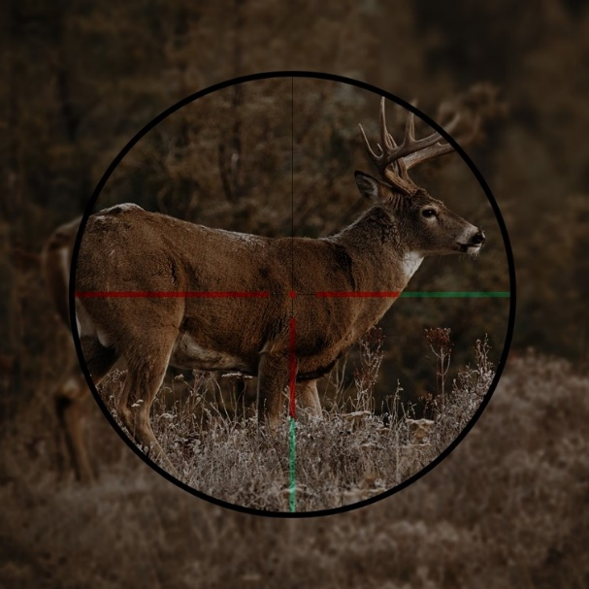
DichroTech Reticle – Day DichroTech Reticle - Dusk

For a limited time, Meopta will be offering these riflescopes with 4D DichroTech reticle at the same price as its non-dichroic # 4 reticle.

Retail Pricing through 3/31/19:
MeoStar R1 3-12x56 with DichroTech 4D Reticle $999.95
MeoStar R1r 3-12x56 with DichroTech 4D Reticle $999.95

Retail Pricing after 3/31/19:
MeoStar R1 3-12x56 with DichroTech 4D Reticle $1,199.95
MeoStar R1r 3-12x56 with DichroTech 4D Reticle $1,199.95

About Meopta
Meopta has been producing high-end European optics for over 85 years. Meopta is a leading manufacturer & partner to many of the world's finest optical brands. Meopta conceives, develops and manufactures precision optical and electro/optical systems for semiconductor, medical, aerospace and military industries as well as for consumer markets.

For more information regarding Meopta, please visit www.meoptasportsoptics.com.

Media Contact:
Shannon Jackson
Shannon Jackson Public Relations
(804) 343-3608
sjackson@shannonjacksonpr.com

###

