PRESS RELEASE
Media Contact:
Keith Reim
Corporate Marketing Manager
keith@solaratm.com
(215) 721-1502

Solar Atmospheres Greenville, SC Receives

Nadcap 18-Month Merit Status

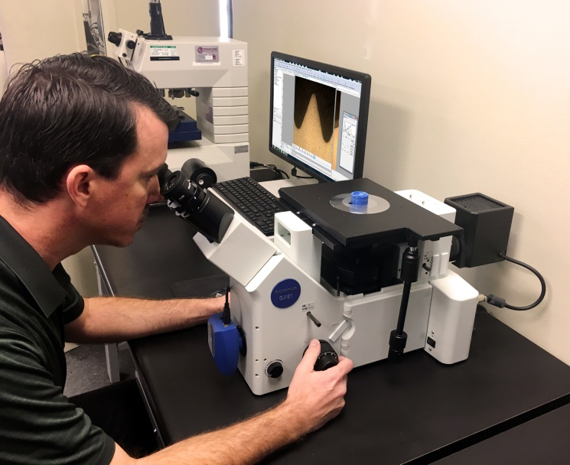
Nadcap recognizes Solar Atmospheres Greenville, SC for its superior performance and commitment to continual improvement in aerospace quality
Greenville, SC, November 5 - Solar Atmospheres – Greenville, SC announces that it has been awarded Nadcap 18-month Merit status for Heat Treating, Brazing and Carburizing. We are extremely pleased PRI has recognized our corporate commitment to quality. Achieving 18-month merit has been a goal set by Solar’s employees since opening its doors in 2015. The adherence to strict specification requirements, flawless process execution, and a daily commitment to quality processing is evident among all employees of Solar Atmospheres.
The Solar Atmospheres Greenville facility has held Nadcap accreditation since 2015. Having demonstrated their ongoing commitment to quality by satisfying customer requirements and industry specifications, the Nadcap Task Group has determined that Solar Atmospheres – Greenville, SC, has earned this special recognition. Instead of having their next Nadcap audit in twelve months, Solar has been granted an accreditation that lasts until 30 April 2020.
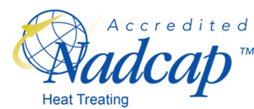
“Achieving Nadcap accreditation is not easy; it is one of the ways in which the aerospace industry identifies those who excel at manufacturing quality product through superior special processes. Companies such as Solar Atmospheres go above and beyond achieving Nadcap accreditation to obtain Merit status and they should be justifiably proud of it,” said Joe Pinto, Executive Vice President and Chief Operating Officer at the Performance Review Institute. “Benefitting from a less frequent audit schedule reduces audit costs and associated pressures and demonstrates the trust that the aerospace industry has in Solar Atmospheres – Greenville, SC based on their past performance in Nadcap audits. PRI is proud to support continual improvement in the aerospace industry by helping companies such as Solar Atmospheres be successful and we look forward to continuing to assist the industry moving forward.”
For more information about the Solar Atmospheres Greenville facility, visit www.solaratm.com, or contact Steve Prout at (864) 970-0111 ext. 1401, or steve@solaratm.com.

About Nadcap
Created in 1990 by SAE Inc., Nadcap is administered by the not-for-profit Performance Review Institute. PRI is a global provider of customer-focused solutions designed to improve process and product quality by adding value, reducing total cost and promoting collaboration among stakeholders in industries where safety and quality are shared goals. PRI works closely with industry to understand their emerging needs and offers customized solutions in response. Learn more at www.p-r-i.org or contact PRI at PRI@p-r-i.org

###
###

