PRESS RELEASE
FOR IMMEDIATE RELEASE
Media Contact:
Keith Reim, Corporate Marketing Manager
keith@solaratm.com
(215) 721-1502

Solar Atmospheres Adds State-of-the-Art 10-bar Furnace

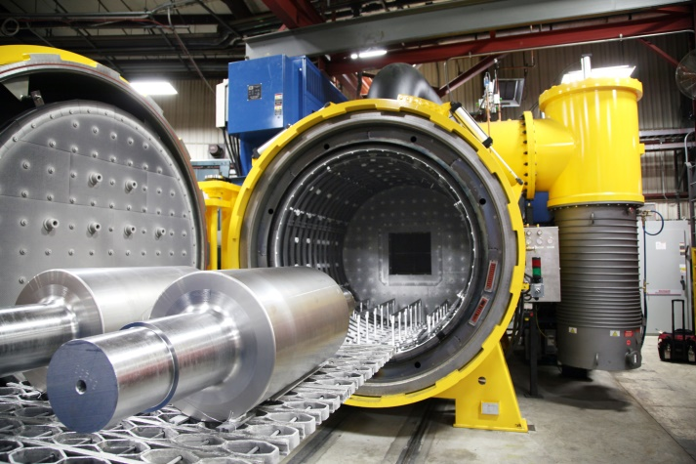
Souderton, PA, March 12, 2018 –
Solar Atmospheres, Inc., Souderton, PA recently installed a state-of-the-art Solar Manufacturing, Inc. 74" diameter by 72" deep horizontal internal quench vacuum furnace at its 1969 Clearview Road facility. The investment totals over 1.8 million dollars, including additional utilities and installation. The furnace is designed to quench with argon at 10-bar while utilizing a 600 horsepower motor running at 460 volts from a variable speed drive, and rear head moveable gas baffle doors. The goal of the massive quench system is to be able to quench larger batches of power generation castings by increasing the cooling rate and eliminating the supplemental use of helium and operating in 100% argon, which has proved successful in operation. The furnace incorporates Solar Manufacturing’s latest SolarVac® 5000 control system, which allows for complete process automation.

“This furnace is a real game changer,” says Solar’s Director of Sales Mike Moyer.

For general purpose heat treating, pictured are two Leadar Roll, Inc., 2,200 lb. rolls, 4,400 lbs. total, heated to 2150°F and quenched in 10-bar N2 and then tempered at 1,000°F. The core material is 4140 with outer case CPM9V, and the as-quenched hardness is greater than Rockwell C 60.

For additional process information, contact Mike Moyer, Director of Sales, Solar Atmospheres, at 215-721-1502 x1207, or mikem@solaratm.com, and visit www.solaratm.com.

For additional furnace information, contact Peter Reh, Vice President of Sales, Solar Manufacturing, Inc., at 267-384-5060, or pete@solarmfg.com, and visit www.solarmfg.com.

###

