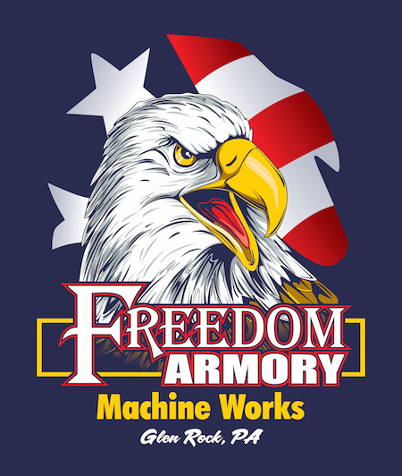
Contact Greg Hofstrand  Telephone 717-801-8492  Cell 717-801-8492  Email greg@tioninc.com  Website tioninc.com | FOR IMMEDIATE RELEASE  January 22, 2019

Tion Inc launched January 2, 2019
In December 2012 the idea that started as a belief and dream became a new division of Freedom Armory Inc. called Freedom Armory Machine Works. During this time Freedom Armory Inc determined that its manufacturing operation should part from its retail operations. Freedom Armory Machine Works separated from Freedom Armory Inc. on January 2, 2019 launching TiON, Inc. as an independent manufacturing corporation. While the name has changed, the revolutionary titanium suppressors and the people supporting them are the same. TiON corporation looks forward to supporting our current and future customers with the same gusto and enthusiasm while sporting a new name and logo.
***
If you would like more information about this topic, please contact Greg Hofstrand at 717-801-8492 or email at greg@tioninc.com. Follow us on www.tioninc.com.

DRAGOON .338 ALL TITANIUM SUPPRESSOR

Lightest and Smallest Serviceable .22LR to .338 Cal Rifle Suppressor in the Marketplace
Glen Rock, PA, January 22, 2019– TiON is proud to introduce the revolutionary Dragoon .338 Rifle Suppressor configured in a Quick Detach (QD) configuration utilizing Total Breakdown Technology (TBT).

“We always get excited about exhibiting at the Shot Show. With so many of our customers and future customers attending the show, we expect a tremendous reception of our latest Titanium Rifle suppressor,” says Scott Morris, TiON President
In a market where heavy, welded, non-serviceable designs are the norm, the Dragoon distinguishes itself with an all Titanium takedown design. The Dragoon is machined from solid Titanium Bar Stock eliminating any weld/failure points and creating an extremely durable and lightweight suppressor that can be serviced down to the piece parts with common tools. But if that is not enough the sound reduction across its entire caliber range is truly astounding for its 9.5” length, 1 3/4” diameter and
22.75 oz. weight, making it a true industry leader.

Our customer Harry said it all, “this is the only rifle suppressor I need, it will cover my needs from .22LR thru the .338 caliber rifles I have and I won’t get tired of carrying it around.”

