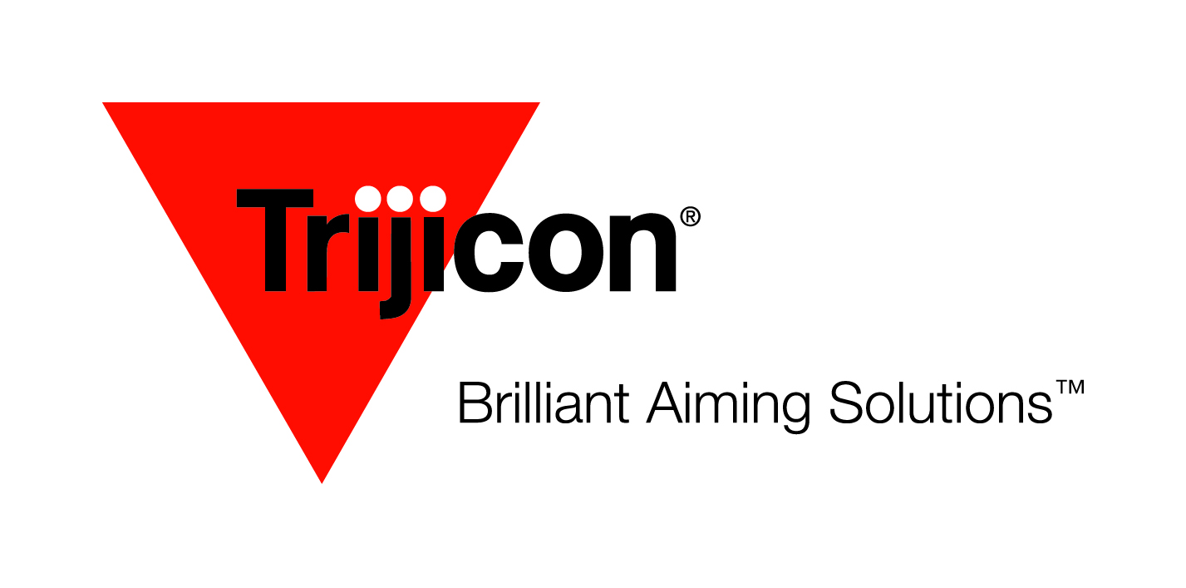
FOR IMMEDIATE RELEASE
Contact: Eddie Stevenson
(540) 420-3467

Trijicon® Adds RMR® HRS to Commercial Offerings

Wixom, MI – Trijicon, Inc., global provider of innovative aiming solutions for the hunting, shooting, military and law enforcement markets is happy to commercially offer a SOCOM version of the Type 2 Ruggedized Miniature Reflex (RMR®) to all U.S. markets.

In August, the Naval Surface Warfare Center Crane Division awarded Trijicon® the contract for the USSOCOM Miniature Aiming System – Day Optic. The five-year contract is for a modified version of new RMR Type 2 sight. This military inspired variant will now be available to all commercial U.S. markets and sold as the Trijicon RMR HRS.

The RMR HRS is anodized in brown and has all the standard features of the RMR Type 2, including audible and tactile windage and elevation adjustments allowing for quick and easy zeroing with no need for special tools or devices. Included with the RMR Type 2, are electronics that are designed to bolster durability and performance in the most punishing environments. The battery contacts increase reliability under the harshest use and stiffest recoil.

Automatic brightness mode and easy push buttons for eight adjustable brightness settings, including two Night Vision and one super bright are key features of the RMR HRS models. The CR2032 lithium battery lasts up to four years at a mid-setting.

A button lockout feature sets the RMR HRS into an automatic mode, preventing accidental adjustments. The sight also has a battery conservation setting; after 16.5 hours, the RMR automatically adjusts the aiming dot to ambient lighting conditions.

Being compatible with existing RMR mounts and optics-ready pistols is a bonus for users.

For more information on the Trijicon RMR HRS Sight or to find dealers near you visit www.trijicon.com or contact Trijicon, Inc. at (248) 960-7700.

For media inquiries and hi-res images, please contact Eddie Stevenson at eddie@driftwoodmediacom.com .

