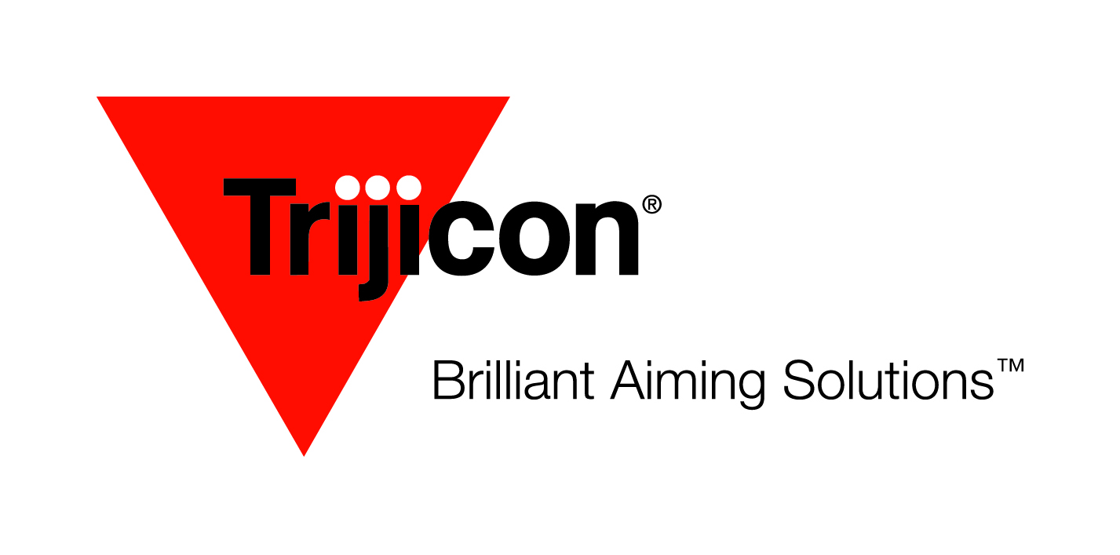
FOR IMMEDIATE RELEASE
Contact: Eddie Stevenson
(540) 420-3467

Trijicon® Adds Green Dot to Miniature Rifle Optic (MRO®) Line

Wixom, MI (May 4, 2018) – Trijicon® Inc, manufacturer of Brilliant Aiming Solutions ™ is pleased to add a green dot option to its MRO® line of sights.

The Trijicon MRO® with green dot continues the legendary dependability of the MRO and features an adjustable 2.0 MOA green dot. The exceptional lens clarity allows the dot to stand out against targets and backgrounds. The human eye is more sensitive to green, making this version of the MRO especially effective for fast target acquisition in low light and transitional lighting conditions.

The MRO with green dot features eight brightness settings, including two that are night vision compatible, plus one extremely bright setting for use with weapon lights or in very bright lighting conditions. The battery will last one year of continuous use at setting three.

The brightness control atop the optic is ambidextrous, allowing the user to adjust the brightness while maintaining fire control. The MRO is parallax free, with infinite eye relief for quick and accurate engagement no matter your shooting position.

With its large objective lens and shortened optical length, the MRO virtually eliminates the “tunnel vision” or tube-effect common to many red dot sights. The 2.0 MOA dot is bright and crisp, and is perfectly sized for fast target acquisition at CQB distances or out to extended ranges.

All Trijicon MRO models mount easily, zero quickly with half-minute adjustments and 70 MOA total travel allow for zeroing on a variety of platforms. Furthermore, no special tools are required—windage and elevation adjustments can be made with the rim of a cartridge casing.

Trijicon engineers built—and tested—the MRO to operate in temperatures ranging from -60F to +160F. Waterproof to 100 feet, chemical and corrosion resistant, and housed in 7075-T6 Aluminum, the MRO can withstand the rigors of combat, sub-zero mornings on an ice-encrusted hunting stand or bouncing between competition stages.

MSRP: $613 without mount; $749 with Quick Release mount.

For more information on the MRO® line and the complete array of Brilliant Aiming Solutions™ for the hunting, shooting, military and law enforcement markets, contact Trijicon®, Inc. at (248) 960-7700 or visit www.trijicon.com.

For Hi-Res images, please contact Eddie Stevenson at eddie@driftwoodmediacom.com or visit www.driftwoodmediacom.com.

