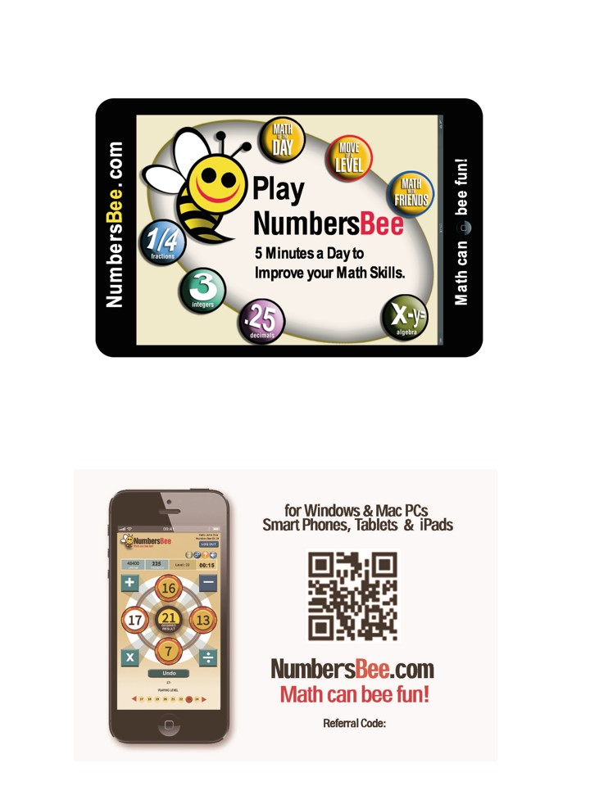

**Improving Numeracy for All and for Life**