Mind Trekkers
Michigan Tech’s Traveling Science & Engineering Festivals

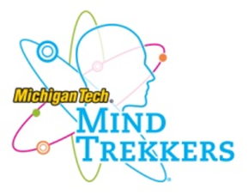
The need for STEM outreach

A vast amount of literature exists that shows how students tend to lose interest in science, technology, engineering, and mathematics (STEM) as they increase in grade level due to: lack of understanding about what a STEM professional does, negative stereotypes and assumptions, and too few opportunities to engage in hands-on, “discovery” learning opportunities. Changing the US STEM landscape to meet future workforce demands will require strategic, expansive, and iterative efforts that spark and sustain a positive interest in STEM. This all begins in our local communities. Michigan Technological University’s Mind Trekkers traveling science & engineering festival provides that important initial spark needed to increase the number of diverse US students attracted to STEM.

What is Mind Trekkers?

Michigan Tech’s Mind Trekkers (www.mindtrekkers.mtu.edu) is a unique and nationally acclaimed science and engineering road show designed to inspire youth to explore the excitement of learning in STEM fields. K-12 students participate in up to 100 innovative and engaging STEM related hands-on activities. Each activity is hosted by a Michigan Tech college student that acts as a near peer role model for the young participants.

The events are designed with these objectives:
“Mind Trekkers is designed to pique inquisitiveness that inspires continued engagement in STEM learning”.

- Steve Patchin, Co-founder, Michigan Tech Mind Trekkers
- First, expose students to the WOW! of STEM through unique hands-on activities that will allow them to define their interests and aptitudes.
- Second, interact with STEM professionals from partnering companies/businesses in the local area allowing them to learn what an engineer, scientist, or master machinist really does.
- Students will be able to speak with representatives from colleges and universities throughout the area, learning what kind of classes they need to take in high school and will take in college in their new found fields of interest.
- Finally, we bring in STEM programs, either in-school or after-school programs, in to show students how they can harness this new found passion for science, technology, engineering, and mathematics. Programs such as F.I.R.S.T. Robotics, Lego League, Destination Imagination, Science Olympiad, Girl Scouts, Boy Scouts, 4H and many others programs are established programs that many students have not considered joining before participating in these high-energy non-traditional festivals.

The overarching goal of Mind Trekkers is to get students into the STEM pipeline: inspiring students to take STEM courses in high school get involved in STEM related afterschool programs, and ultimately pursuing STEM related careers.

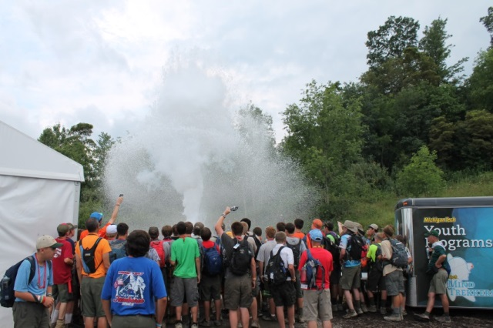
History of Mind Trekkers

The initial vision for Mind Trekkers started in 2010 at a National Boy Scout Jamboree. Michigan Tech’s Center for Pre-College Outreach recruited 12 undergraduates to create a synergistic crew of scientists, engineers, mathematicians, and technology gurus to implement a series of hands-on activities that engaged 42,000 Jamboree participants in STEM discovery. The event exceeded expectations and what followed was a persistent commitment by Michigan Tech’s Center for Pre-College Outreach and undergraduate students to establish a student Mind Trekkers organization that was dedicated to developing a continuous set of hands-on activities that “prime the pump” and engage more K-12th graders in STEM learning. After diligent work and continued momentum for high expectations, Mind Trekkers became established and trademarked in 2012 with over 500 passionately engaged student members. Mind Trekkers is now serving as a national model of STEM outreach, recognized by STEM educators both locally and nationally.

Is Mind Trekkers making a difference?

Pre/post event student surveys were introduced at the Kohler Sheboygan Science & Engineering Festival which took place in April 2012, reaping very positive outcomes. Similar surveys are now conducted at all Mind Trekker events.

Community Partners

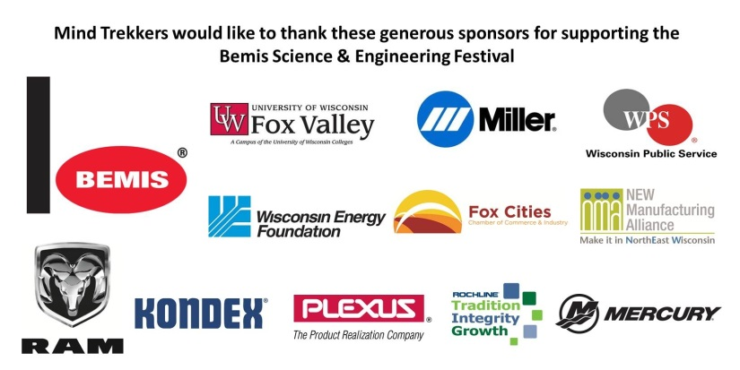
Corporate, foundation, and university funding has been key to the success of Mind Trekkers since its inception in 2010. Events are funded by corporate sponsorships, community foundation grants and community organizations. Michigan Tech also invests in the Mind Trekkers program by providing partial staff salaries and travel expenses. It’s impressive to note that the 500+ Michigan Tech students in the Mind Trekkers student organization are volunteers and receive no compensation (other than travel expenses) for their incredible efforts.

Partnership with the USA Science and Engineering Festival

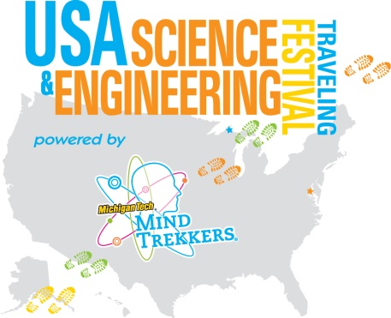
Mind Trekkers took part in the 1st USA Science and Engineering Festival in Spring of 2011. The impact of Mind Trekkers had on the 500,000 event visitors was recognized by the sponsors of the Festival. Mind Trekkers has teamed up with the USA Science and Engineering Festival to represent the USA Festival at other STEM Festivals throughout the country such as The Bay Area Science Festival in San Francisco (25,000+ visitors), the 2013 National Boy Scout Jamboree at The Summit in West Virginia (40,000+ participants), and the 2015 FIRST Championships in St. Louis (40,000+).

Future Events

Mind Trekkers has conducted or participated in over 70 STEM festivals and events throughout the country since its creation in 2010 which have hosted over 1,000,000 students and their parents. Future events include:

- Northeast Wisconsin Technical College Science Festival - Green Bay, WI – February 2016
- Adventures in STEM Houston Area Science Festival - Houston, TX – March 2016
- National Society of Black Engineers National Convention - Boston, MA – March 2016
- Independence School STEMfest - Newark, DE – April 2016
- USA Science and Engineering Festival - Washington, DC – April 2016
- Exploration Sensation Science Festival - Sault Ste. Marie, MI – May 2016
- Dow Chemical Great Lakes Bay STEM Festival - Midland, MI – September 2016
- Wausau Area Science & Engineering Festival - Wausau, WI – October 2016
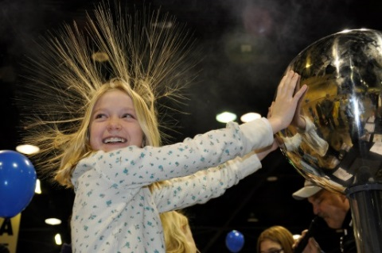
- SE Michigan Science Festival – Detroit, MI – October 2016

This is our schedule so far, with many others in the works. Keep track of the updates on our website at: http://mindtrekkers.mtu.edu/ .

What are is the Future of Mind Trekkers

Michigan Technological University’s Mind Trekkers program is tailoring its future to the needs of those for whom they serve:

Teachers - we are constantly creating new activities that fit our model – 30 seconds to 3 minutes in duration that bring the WOW! of STEM to the fingertips of students. Our Mind Trekkers put these in lesson plan format so they can be replicated and share them on our Mind Trekkers website so anyone can create them on their own. We use the feedback from teachers to help us determine kinds of activities to create to support their efforts in the classroom, the latest being incorporating Arts into our STEM activities.
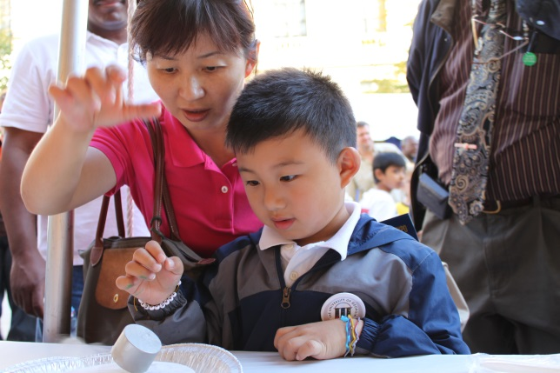
Students – we are piloting our Mind Trekkers afterschool program, allowing these clubs of middle/high school students to learn or create STEM activities in this format. They then conduct these activities in their own mini-Mind Trekkers events for K-6 students. This ‘Cascade Mentoring’ model is the future of integrating a culture of STEM that will ignite and sustain the inquisitive nature in each student from cradle to career.

Educational and community leaders – as we develop the Mind Trekkers program and the extended services we offer, we continue to be mindful of keeping our operating expenses low and searching for ways that our programs can support the fundraising efforts of the schools and communities to support exciting STEM initiatives in their areas.

Corporations/Businesses/Foundations – our corporate partners are constantly seeking ways to ensure a talented pool of life-long learners to fill their workforce needs in the future. Mind Trekkers continues to work on development of ‘innovation alley’ where participants can explore new technological advancements, allowing students to begin dreaming of what they can create using their STEM education.

Social Media – Mind Trekkers is developing ways to keep interactive discussions going about STEM. Facebook, Twitter, YouTube are just a few of the vehicles we are using to develop an ongoing conversation that channels the energy from the events they attended to actions that keep them engaged in STEM clubs, courses, and career exploration.

The Mind Trekkers program continues to develop innovative research based programming with the purpose of inspiring students to Discover the Science Behind the Mystery they are experiencing. We look forward to working with organizations that share our mission and sense of urgency to ignite each students sense of inquiry into the world of science, technology, engineering, and mathematics.

Come Discover with Us!

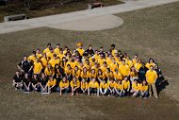
For more information, contact:
Cody Kangas, Director
email: cody@mtu.edu
phone: 906-487-2219
Michigan Technological University
1400 Townsend Drive
Houghton, Ml 49931-1295

