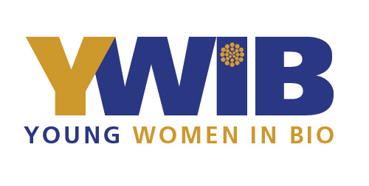

Washington DC/Baltimore

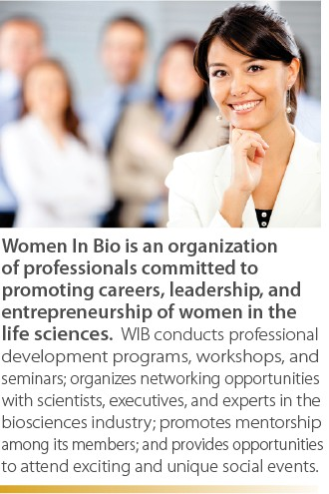
Young Women in Bio-Washington, DC/Baltimore

Women in Bio (WIB) (www.womeninbio.org) is the ONLY non-profit, volunteer organization for women that integrates all careers and levels in the life sciences. As part of the WIB organization, Young Women in Bio (YWIB) is a special initiative of WIB, designed to introduce middle and high school-age girls to careers in science, technology, engineering and math (STEM).

Young Women in Bio-Washington, DC/Baltimore engages in many outreach events throughout the year. We arrange diverse educational opportunities from lectures, hands-on experiments, site tours and networking sessions with the industry’s leading academic and for-profit institutions. Past partnserhips include MedImmune, Proctor & Gamble, University of Maryland and Emergent Biosolutions. Finally, YWIB often works directly with schools, supporting student clubs and hosting disucssions with teachers around current advances in the biotech industry.

Mission Statement
Our mission is to reach out to middle and high school-age girls and introduce them to careers in science, technology, engineering, and math (STEM), and to continue to serve as mentors as they navigate their path toward STEM careers.

What does YWIB-Washington, DC/Baltimore do?
Contacts:
Elise Hartley : Chair (elise.c.hartley@gsk.com)
Eka Reider: Co-Chair
(ekareider@gmail.com)

http://womeninbio.org/ywib
https://www.facebook.com/ youngwomeninbio
@NationalYWIB

- Organizes interactive outreach events to middle and high-school girls to introduce STEM-related realms and career options;
- Arranges visits to biotech facilities to provide opportunities for on-site
observation of STEM careers, interactions with staff, and hands-on experiments;
- Conducts discussion panels where professional women share with high school and middle school girls their educational backgrounds, career path and experiences;
- Hosts events to expose high school teachers to current advances of the biotechnology industry and provide them with resources to share with their students.

How Do I Get Involved?

- If you are a professional in STEM-related fields:
➢ Join today www.womeninbio.org
➢ Sponsor an event
➢ Become a volunteer
- If you are an educator or a parent:
➢ Invite us to your school
____________________________________________________________________________________________________________________________________________________
Chapter Sponsors

