Click here to view this message in your browser
Public Voting Now Open for Generation Nano Superhero Contest
Winners to be announced by Wil Wheaton on main stage at USASEF

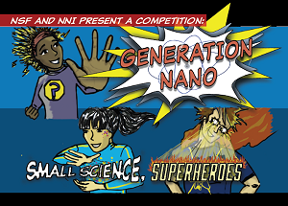
(April 7, 2016) Public voting is now open for the Generation Nano: Small Science, Superheroes competition, sponsored by the National Science Foundation (NSF) and the National Nanotechnology Initiative (NNI), and championed by many, including superhero legend Stan Lee. Members of the public are now invited to vote for the People's Choice award from 11 semifinalists. Visit http://bit.ly/1ROKtLI to view the semifinalists and cast your vote today!
Winners of the contest will be announced by Wil Wheaton—a regular on The Big Bang Theory and former Star Trek cast member—on the main stage at 2016 USA Science & Engineering Festival (USASEF) at 10:30 a.m. on April 17, 2016.
To learn more about nanotechnology, visit Nano 101 on Nano.gov.

Media Contact:
Marlowe Newman
703-292-7128
mnewman@nnco.nano.gov

